**TerraProbe Soil Sampling Robot**

Final Design Review

ME463: Senior Design

1 May 2025



**A Down 2 Earth (D2E) Company**

**Awadhoot Ghatge, Christopher Meyers, Jacob McKenrick, Lokesh Sriram, Sankaran Iyer**

# **Executive Summary**

The agricultural industry is striving to optimize crop productivity through data-driven solutions. However, traditional soil testing remains expensive, slow, and labor-intensive, limiting timely decision-making. Down2Earth addresses this gap with TerraProbe, a cost-effective, portable, and efficient soil analysis system. By integrating real-time data collection with a hybrid auger-core sampling mechanism, TerraProbe enables multi-depth soil profiling and predictive recommendations, empowering farmers to make informed decisions.

TerraProbe consists of two core components: a soil-sampling robot and an integrated testing probe. The lightweight 11.8 kg (approximately 26-pound) system features a rack-and-pinion mechanism, powered by dual DC motors, to drive the sampling payload into the soil with precision. An ergonomic foot pedal assists in applying additional force as needed. The probe is equipped with sensors that measure moisture and NPK (Nitrogen, Phosphorus, Potassium) levels, displaying results via a dashboard for real-time health assessment.

Since the Critical Design Review (CDR), significant progress has been made in design, manufacturing, and testing. A full prototype was manufactured and assembled using refined manufacturing drawings and process plans. Testing validated the system’s portability, real-time data acquisition, and dashboard functionality. However, challenges emerged in motor torque performance, depth penetration, and wiring reliability. The current prototype successfully achieved sampling depths of up to 6.5 inches, but struggled to reach the 12-inch target, primarily due to motor limitations.

Throughout testing, TerraProbe demonstrated many of its functional requirements. A neural network model was developed to generate crop recommendations based on real-time soil sensor data, achieving a model accuracy of 92.2%. However, the system also showed limitations in dry soil conditions where deeper sampling was inconsistent, and occasional wiring issues impacted data capture reliability.

Moving forward, the key steps have been identified to enhance TerraProbe’s design and scalability:

1. Component Upgrades: Installing higher torque, 50 RPM motors and upgrading to a 24V power system for better penetration.
2. Manufacturing Refinements: Expanding the baseplate, improving cable management, and optimizing cleaning and maintenance features.
3. Electronics Improvements: Developing a custom PCB to streamline wiring and enhance system durability.

At the Final Design Review (FDR), TerraProbe successfully met several critical milestones, including full prototype assembly, sensor integration, real-time dashboard visualization, and functional soil sampling tests. Although certain performance targets such as full 12-inch sampling depth and autonomous operation were not fully achieved, the current system captures reliable soil samples to a depth of 6.5 inches. These outcomes validate TerraProbe as a functional Minimum Viable Product (MVP), demonstrating a strong foundation for further refinement and market entry.

Financially, TerraProbe's prototype was developed within a cost range of approximately $862, positioning the final device at an estimated sales price of $1,100 per unit. This intermediate pricing offers small/medium-sized farms an affordable alternative to expensive lab-based soil testing, while opening opportunities for recurring revenue through sensor tube replacements and dashboard fees.

TerraProbe’s vision is to revolutionize soil sampling with an on-demand, portable, and efficient solution, delivering real-time analytics across various soil depths. By providing accurate, data-driven insights, TerraProbe empowers agricultural professionals to optimize crop yields and enhance soil health management worldwide.

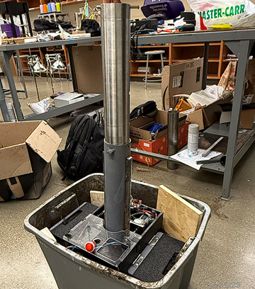

**Figure 1: TerraProbe Minimum Viable Product (MVP)**

Table of Contents

Executive Summary 2

Introduction 5

I. Identifying the Problem 5

II. Understanding the Stakeholders & Market 5

III. Final System Design 8

IV. Manufacturing and Assembly 17

V. Simulation-Analysis and Validation Testing 22

VI. Failure Modes & Risk Management 26

VII. Insights into Future Design Iteration 27

IX. Conclusion & Next Steps 30

APPENDIX 31

A.1 - Project Management 32

A.2 – Business / Marketing 36

A.3 – Design Process 46

# **Introduction**

# **Identifying the Problem**

The Down To Earth (D2E) team has identified a significant gap in the soil sampling market. Soil sampling plays a crucial role in agriculture, environmental monitoring, and geotechnical engineering. Reliable soil analysis provides insights into soil composition, fertility, contamination levels, and mechanical properties. However, traditional soil sampling and testing methods involve several challenges including inconsistencies in sample collection due to heavy bulky equipment, soil contamination between depth layers, and inefficiencies in manual operations. These limitations hinder the accuracy of soil assessments, leading to suboptimal decision-making in farming, land development, and environmental remediation. The market consists of either manually operated soil sampling equipment or complex, bulky machinery that require skilled access to greater soil depths. This presents an opportunity for an intermediate solution, a device that is portable, efficient, and capable of borrowing and collecting soil samples at multiple depths without compromising sample integrity (Refer to Appendix A.2)

To address this gap, we intend to build TerraProbe, a soil sampling robot specifically designed for small to mid-sized farmers who cultivate a limited variety of crops. Unlike large-scale agribusinesses with access to industrial-grade soil testing solutions, these farmers often lack affordable, efficient tools for precise soil analysis. TerraProbe aims to bridge this gap by providing an accessible, easy-to-use, and data-driven solution tailored to their needs. The system will efficiently burrow into the soil, extract samples at various depths, and provide a soil testing probe that collects real-time data through an integrated dashboard, displaying critical soil properties such as NPK (Nitrogen, Phosphorus, Potassium Concentrations) and moisture. Our vision is to revolutionize soil sampling and monitoring by delivering an on-demand, portable, and labor-efficient solution that offers real-time analytics across different soil depths. The device will not only provide a method to accurately excavate and extract soil samples but also provide data on-site instead of requiring testing at the lab. TerraProbe is a tool not only for farmers and agronomists but eventually has the potential to become a daily household solution that will enable data-driven decision-making to optimize crop yield, improve construction planning, and promote sustainable land management practices globally.

# **Understanding the Stakeholders & Market**

In the agricultural market, the need for more efficient, accurate, and accessible soil testing is becoming increasingly important. Our primary and target consumers are farmers and agronomists who require the collection of soil samples to analyze properties at various depths. Specifically, TerraProbe’s target consumer is designed primarily for small to mid-sized farmers who cultivate a few crops and often lack affordable, efficient soil testing solutions. Currently, according to a study by Crop Nutrition, only 10-15% of fields in small-grain farming regions undergo annual soil testing, largely due to the high cost and time commitment associated with third-party services. With soil testing prices varying by region and increasing due to rising fuel costs, many farmers forgo testing altogether, leading to suboptimal soil management and lower crop yields for many small-scale farmers.

The global soil testing market, valued at $5.5 billion in 2023, is experiencing significant growth, driven by the expanding adoption of precision agriculture technologies.

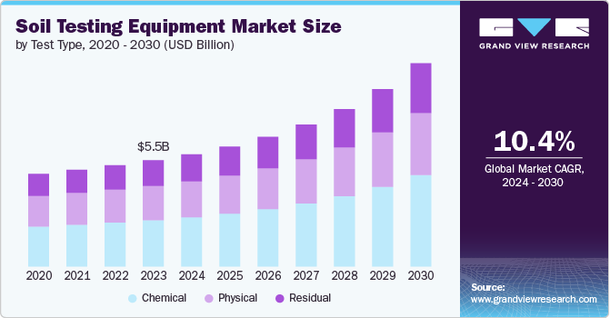

**Figure 2: Market Growth**

As shown in Figure 2, with a compound annual growth rate (CAGR) of 10.4%, the soil testing market presents a strong opportunity, particularly given the inefficiencies of existing solutions. In the U.S. alone, there are 1.8 million total farmers. Roughly 671,000 of these are small to medium-acreage farms who align with TerraProbe’s target consumers. Assuming a conservative 20% adoption rate, this represents a potential market figure of 134,200 units. TerraProbe’s innovative offerings—combining autonomous soil burrowing system with integrated data collection and real-time testing probe—creates multiple revenue streams, including unit sales and recurring subscription services for advanced analytics. With rising costs and labor-intensive processes limiting widespread soil testing, TerraProbe offers an efficient, affordable, and scalable solution, making it well-positioned to address this growing market demand.

|  |  |  |
| --- | --- | --- |
| [**AMS Soil Probes**](https://www.ams-samplers.com/soil-probes/?srsltid=AfmBOooCz73JXL5CJCZstnSxcL71dH0DrRpJWqvqxQZTRj4dp-7FCFa0&utm_source=chatgpt.com)  7/8" X 21" Soil Probe w/ Handle, 5/8" Thread | A green and yellow vehicle  Description automatically generated[**WintexAgro 1000 Automatic Soil Sampler**](https://wintexagro.com/products/wintex-1000/?utm_source=chatgpt.com) | A tractor in a field  Description automatically generated[**Amity Technology Soil Sampler**](https://www.amitytech.com/crop-management-tools/soil-samplers/) |

**Figure 3: Benchmark Models**

Figure 3 showcases a few examples of the benchmark solution. Currently, market alternatives range from low-cost, manual soil probes to high-end automated systems. For instance, AMS soil probes, which are simple and cost-effective, are manual and lack depth accessibility, automation, and data integration. On the other end of the spectrum, products like the Amity Technology Soil Sampler are highly automated, capable of sampling to depths of 48 inches, but they come at a high price range of $3000-$6000 and lack portability or real-time data analytics as they require mounting on vehicles and third-party data acquisition systems. While the WintexAgro 1000 provides some automation, its shallow depth capacity (up to 30 cm), bulky and heavy equipment, and lack of integrated data analysis further highlight the gaps in existing solutions.

A core feature and vision of our product, TerraProbe, is the real-time data collection and autonomous soil sampling, especially in challenging soil conditions like soft clay. This feature not only differentiates TerraProbe but also positions it as an asset for both precision agriculture and other industries such as construction and environmental research. Unlike AMS probes or the Wintex 1000, TerraProbe will combine portability (≤ 25 kg), autonomous operation, and multi-depth sampling (up to 12”) with integrated sensors for moisture and NPK concentrations, offering real-time data analysis that none of the benchmark products can provide. While farmers are the core target, firms in the geotechnical investigation space, including companies like Fugro and AECOM, as well as environmental monitoring organizations like NASA and the USDA, also stand to benefit from TerraProbe’s capabilities.

TerraProbe will be launched in the market to balance affordability, go-to-market strategy, and long-term profitability through a dual revenue model. Our product strategy leverages a product line and services business model. TerraProbe consists of two core components: the soil burrowing robot and the testing probe, both of which we will sell at a low profit margin of approximately 25% to remain competitive and drive adoption. With an estimated production cost of $800-$850, we will price TerraProbe between $1000-$1100, making it an accessible and cost-effective solution for small and medium-acreage farmers.

To ensure sustained revenue and customer retention, we will leverage a service-based model with two key streams:

1. Modular Inner Tubes – These replaceable storage units house soil samples within the robot and will be sold as recurring items to test multiple times.
2. Analytics Subscription – Farmers can access real-time soil health insights through our integrated software platform, offering actionable data for precision agriculture.

This strategy not only lowers the initial barrier to entry but also establishes a recurring revenue stream, ensuring long-term engagement with customers. By offering a competitively priced hardware solution alongside indispensable consumables and data services, we create a scalable go-to-market approach that aligns with the needs of small-scale farmers while positioning TerraProbe as a cost-efficient, high-value investment in soil testing. Further economic projections and financial modeling are detailed in the Economic Analysis section below (Additionally, refer to Appendix A.2 for more details on Market Analysis).

# **Final System Design**

The final prototype was developed with the goal of meeting key functional requirements that would ensure practicality, performance, and affordability for end users. Critical features for TerraProbe, derived from bottlenecks in existing solutions, included portability for field use, motorized operation to reduce user fatigue, and a dual auger-core sampling mechanism to extract soil samples at multiple depths. The system was also expected to handle varying soil types and compactness levels, while integrating a motor control system capable of consistent rotational force. Additionally, the prototype incorporated an NPK sensor for real-time soil nutrient analysis and a dashboard machine learning model to provide accurate field insights. The table below summarizes the targeted versus actual performance metrics for the final system.

**Table 1: Comparison of Target vs. Actual Functional Performance**

|  |  |  |
| --- | --- | --- |
| **Requirement** | **Target** | **Actual** |
| Portability | < 25 kg, compact | 11.8 kg, 9” x 12” x 16.5” |
| Motorized Operation | Run independently without user effort | Has Motorized Operation but requires user supervision and careful assembly |
| Auger/Core Sampling Mechanism | Sample down to 12 inches | Sample down to 6.5 inches |
| Depth Accessibility | Distinct samples from 0-2 in, 2-4 in, 4-8 in, 8-12 in | Distinct samples obtained from 0-2 in, 2-4 in |
| Soil Type & Compactness | Devices should be burrowed through different levels of soil compactness | Easily burrows through cohesive soil but not dry soil |
| Motor Control | Provide a minimum of 30 RPM force and 400 lbf. | Provides ~22.5 RPM and 120 lbf. max Force |
| NPK Data Capture | Read Values for Nitrogen, Phosphorous, Potassium | Functions as intended and captures moisture as well |
| Dashboard & Crop Recommendation | >85% Model Performance Accuracy and Dashboard Visualization | 92.2% Model Accuracy and Interactive User Dashboard Presented |
| Cost Efficiency | Prototype Development Cost from $600-1000, with sell price <$1500 | Prototype Development cost |

While the final prototype successfully met the majority of the targeted functional requirements, certain limitations were observed, particularly in achieving the desired sampling depth. The reduced sampling capability was primarily attributed to the motor’s lower-than-expected performance, which limited the system’s ability to burrow effectively through denser soil layers. Despite this, the prototype demonstrated strong performance in portability, motorized operation (with some supervision), soil nutrient data capture, and machine learning model accuracy. Detailed testing procedures and results that led to these findings are presented in the Testing and Validation section below. Additionally, potential design enhancements to improve sampling depth, motor performance, and overall system robustness have been outlined in the Future Design Plans section to guide future development iterations.

* 1. **Core Design Concept**

The TerraProbe system is an all-in-one solution that integrates mechanical sampling, immediate soil analysis, and software-based analytics to enable users to obtain critical health information without relying on external lab service. The system is comprised of three interconnected components – TerraProbe, TerraPal, and TerraSoilIQ.

TerraProbe – Soil Burrowing Robot:

* A compact, motorized soil collection device that utilizes a rack and pinion mechanism to burrow into the soil and extract soil samples.

TerraPal – Integrated Testing Probe:

* A portable soil testing unit that measures important soil parameters such as moisture, nitrogen, phosphorous, and moisture collected from various depths of the burrowed soil, enabling real-time nutrient analysis in the field.

TerraSoilIQ – Intelligent Dashboard:

* A dashboard to visualize nutrient data obtained from TerraPal, providing individual metrics and depth profiles. Additionally, a machine learning algorithms processes sensor data for crop recommendation based on soil properties.

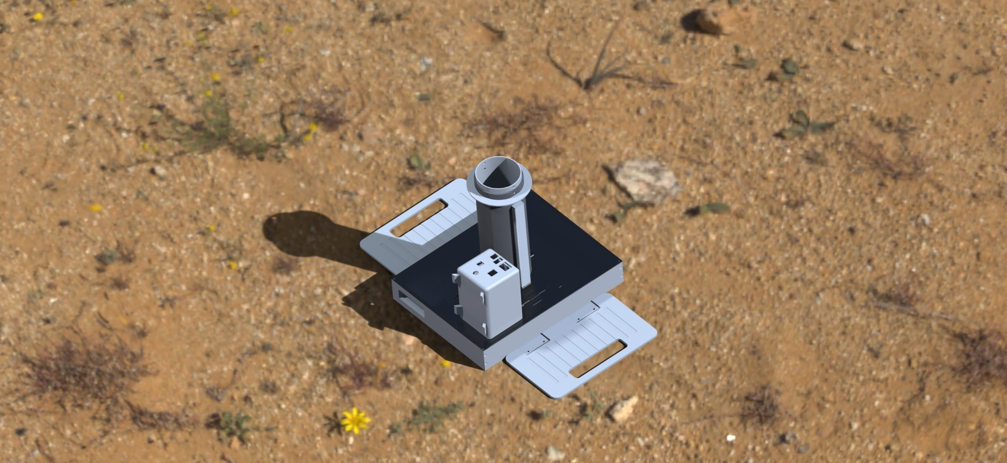

**TerraProbe**

**TerraPal**

**Figure 4: TerraProbe / TerraPal Design**

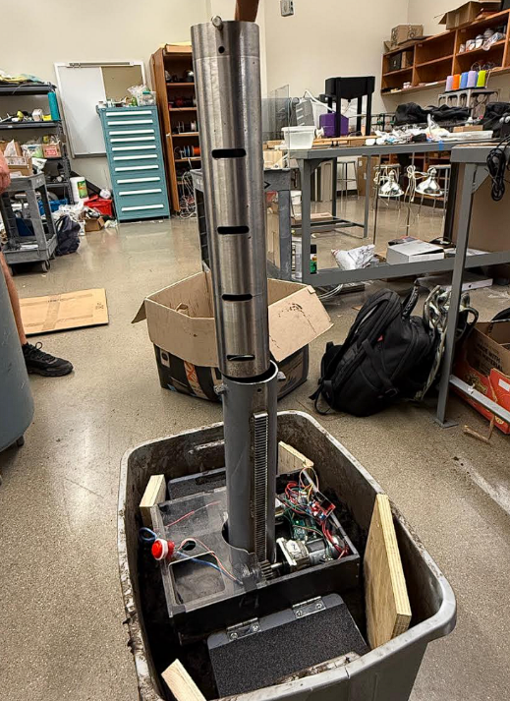

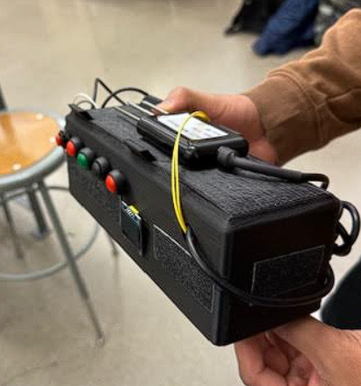

**Figure 5: TerraProbe Final Assembly**

* 1. **TerraProbe – Burrowing System**

TerraProbe has been formulated adhering to the design requirements and constraints listed above. TerraProbe is designed to be compact with dimensions of 10” wide by 12” long by 16.5” tall. Additionally, it weighs 26 pounds/11.8 kgs, which is much lighter compared to alternative solutions, which can be as heavy as several hundred pounds. The system operates through a rack and pinion mechanism that drives a soil-collecting payload into the ground. The overall design consists of a sturdy base housing all motors, gears, and electrical components, along with an outer shell and an inner payload chamber responsible for soil collection. The device features foldable foot pedals to provide additional downward force, a removable top lid for easy maintenance, and a built-in limit switch to prevent the payload from travelling too far into the ground.

At the heart of TerraProbe’s soil collection mechanism is a two-part penetration system consisting of an inner payload and an outer shell. The inner payload is a 16.5-inch-tall chamber with a 1/16” thickness to reduce soil displacement. The outer shell, which encases the payload, contains gear racks welded vertically along its sides and a chamfered base to facilitate smooth soil entry. The payload is locked into place on the shell using a quick release pin, so that the payload does not slide relative to the shell during the entry phase. Once the sample is collected, the payload can be removed from the outer shell using the same pin however in the hole right above the height, preserving the soil layers for analysis.

The rack and pinion system are powered by two DC motors housed within the base compartment (refer to the appendix to see the electrical schematics and. A ¾” face-width gear engages with the rack, driving the outer shell and payload downward. Ball bearings support the rotating axles, ensuring smooth and efficient motion. As the probe advances, soil enters the inner payload chamber, maintaining its stratified structure. Upon retrieval, the payload can be probed through 4 horizontal slits to measure soil properties at varying depths. The system is designed to operate autonomously, enabling users to collect multiple-depth samples without manual force, ensuring accurate soil profiling with minimal effort.

This modular inner payload design offers two main benefits:

* Provides flexibility for soil to be analyzed both in-field using sensors or sent to a lab for further testing – plastic lids can be used to transport the collected cores
* Allows for multiple soil tests using a single machine

There was several manufacturing methods used to realize our CAD model. Mills, lathes, water jets, laser cuts, and welds were used to manufacture stock parts. 3D printed parts were used on parts that were too complicated to manufacture/ bear minimal load. You can find more on the same in the Manufacturing section ().

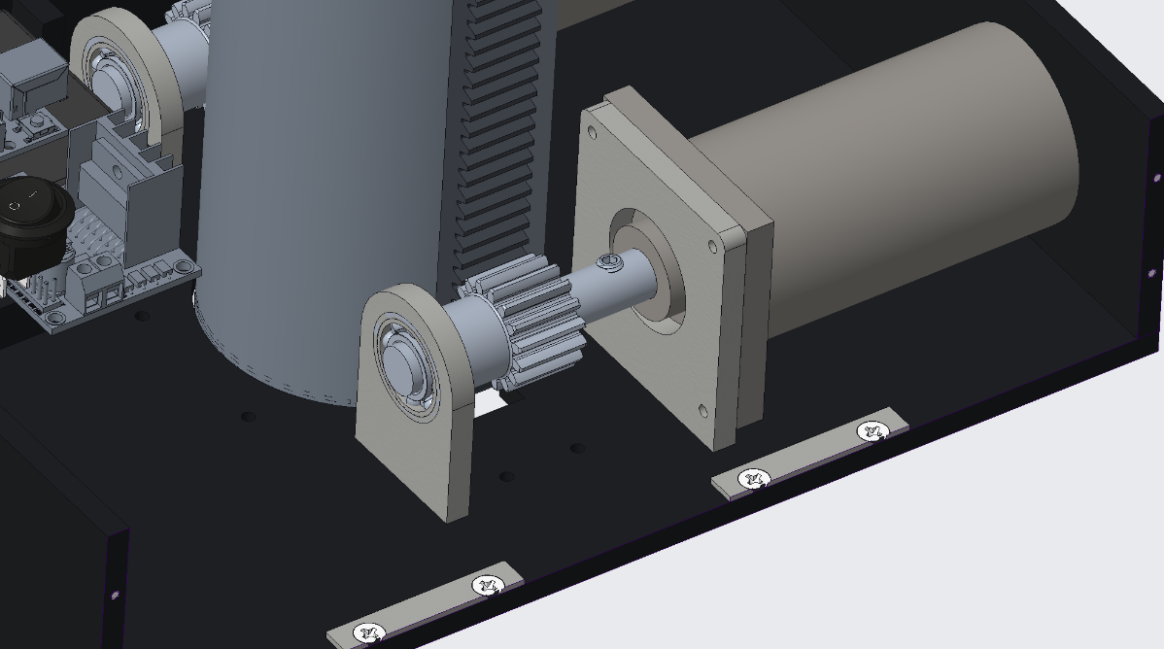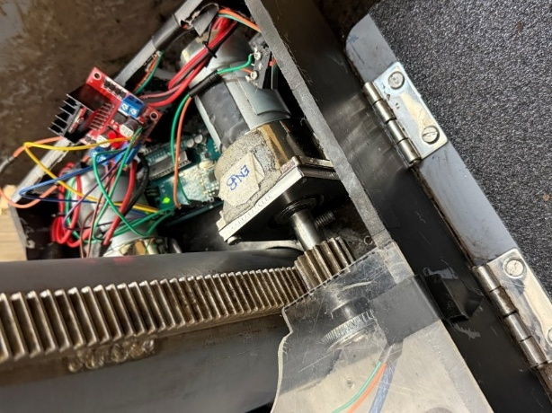

**Figure 5: Rack & Pinion, Motor, Shaft System**

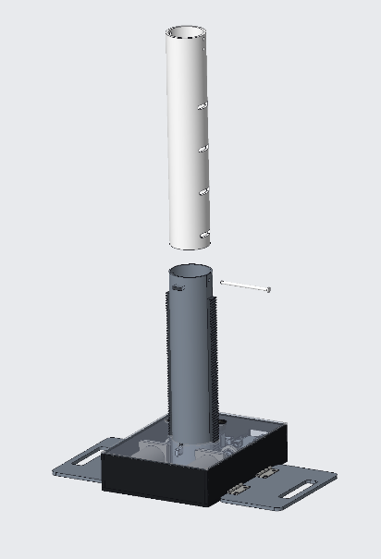 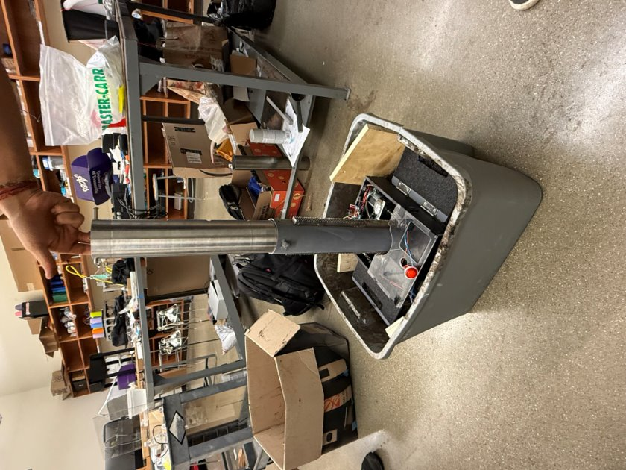

**Figure 6: Inner & Outer Payload**

There were several small changes from the CAD model to the actual prototype:

* The through holes on the base plate were made bigger than intended to allow for slight adjustments when meshing the racks with the pinion gears
* For the same reason, the shell guide was removed from the design. The shell guide was engineered to be a slip fit but due to 3D printing turned out to be an interference fit. It was also designed assuming both the motors would run at the same speed/power all the time – which wasn’t the case in real life. So, the guide often caused the racks and gears to un-mesh during operation.
* The lid was sawed in half and only one half was kept. This was done due to assembly difficulties. The plastic, waterjet, lid interfered in several places with the racks and the shell circumference. Band sewing it in half allowed for movement as needed.
* The collar to hit the limit switch was changed from circular to just tabs. This allowed us to save sheet metal stock for other purposes in case something failed during testing
* The screws on the foot pedals were bolted as during testing the foot pedals screws often stripped due to the forces experienced and weight applied by the user.
* Originally, the payload internal walls were purposely made as smooth as possible. However, this feature was changed because while the the soil is cohesive enough, the soil kept slipping out as a column. Hence, we added some grip tape to provide some friction to better grip the soil.
  1. **TerraPal – Testing Probe**

To complement the mechanical sampling system, TerraProbe integrates an advanced soil testing probe for in-field analysis. The TerraPal module consists of multiple soil sensors extending from its base, allowing insertion through the pre-designed slots in the inner payload chamber to directly analyze the collected soil samples. The primary sensing unit is the Taidacent RS485 Soil Sensor, which measures nitrogen (N), phosphorus (P), and potassium (K) levels, essential for evaluating soil fertility. Additionally, moisture sensors are included, providing real-time assessments with accuracy levels of ±5% for moisture and salinity and ±1°C for temperature.

The electronic components — including an Arduino Mega, SD card holder, transceiver module, and associated wiring — are housed within a 3D-printed PLA casing (Refer to Appendix A.3 CAD Files for Wiring Diagrams). Initially, the casing was designed with compact dimensions (3.0” x 6.5” x 2.0”), but during assembly, we identified the need for improved wire management and connector clearance. As a result, the final casing dimensions were increased to 5.0” x 9.5” x 2.0”, providing more internal space to prevent pinching or disconnection of wires during handling.

The probe features a single LED screen on top, used for guiding the user through the data collection process. The program starts by resetting the SD card and clearing any previous data in the .txt file. The user then presses dedicated buttons for each sampling depth slit (e.g., 0–2", 2–4") to record data from the corresponding soil layer. All collected sensor readings are automatically stored into the SD card, allowing easy retrieval and further analysis.

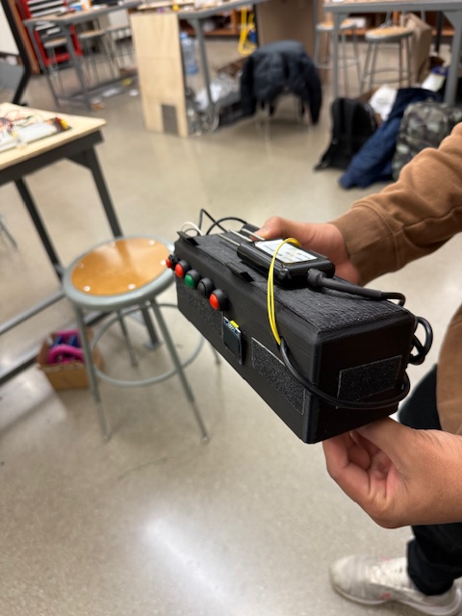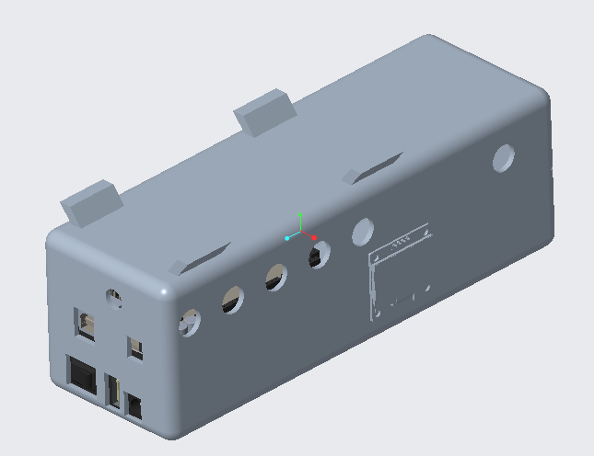

**Figure 7: TerraPal Soil Testing Probe**

During the assembly phase, we encountered challenges with loose wires and limited space for routing connections, especially around sensor inputs and SD card interfaces. To resolve these issues, we soldered critical connections and reorganized wire paths to secure them within the casing, improving the overall durability and reliability of the data acquisition system. Special attention was given to minimizing mechanical stress on the connectors to ensure long-term performance in the field.

Several design refinements were necessary to translate the initial CAD model of the TerraPal Soil Testing Probe into a functional, reliable prototype:

* Enlarged Casing Dimensions: The original design specified casing dimensions of 3.0” x 6.5” x 2.0”. However, during assembly, it was noticed that the wires routing the buttons hindered with the battery. To accommodate the Arduino Mega, SD card module, and necessary wiring without risk of disconnection, the casing was enlarged to 5.0” x 9.5” x 2.0”.
* Button Integration and LED Screen Adjustment: Initially, the design called for 2 LED displays. However, due to power and space constraints, the design was simplified to one centralized LED screen, with user prompts for button presses corresponding to different slits. This made the user interface more intuitive and reduced the overall component complexity.
* Wire Management and Soldering: In the CAD model, wiring was not a major constraint. The SD card module wiring was very crucial for reading and writing to the text file. The prototype required careful soldering of key wires to prevent loose connections during field operation.
* Access Panel for SD Card: To enable easier retrieval of the SD card, a small cutout panel was added to the casing, allowing users to access the card without fully disassembling the casing.
* DAQ Program Revisions: Based on physical assembly testing, the Arduino program was revised to include a reset sequence at startup that clears old data from the SD card.

Through careful design refinement and hands-on troubleshooting, the TerraPal system was successfully built into a robust, portable DAQ solution that directly complements the soil sampling workflow of TerraProbe.

* 1. **TerraSoilIQ – Dashboard**

To complement the data collection capabilities of TerraPal, TerraSoilIQ provides a digital interface that translates raw data collected through the SD card into actionable insight for the user. Without an easy-to-use dashboard, the rich information collected would be difficult to analyze and interpret effectively. TerraSoilIQ bridges this gap by providing real-time soil analytics and intelligent recommendations in a user-friendly, portable format.

TerraSoilIQ is directly connected to the output of the TerraPal Testing Probe. After sampling, users simply retrieve the SD card containing the TEST.txt file and place it into the same folder as the TerraSoilIQ software package. Upon launching the software, the program automatically reads and processes the data without requiring manual file uploads or additional formatting, ensuring a seamless experience.

The dashboard is built using Python and Streamlit, providing a lightweight, responsive, and accessible user interface. Key features include:

* Metric Overview Panels: Users can view Nitrogen (N), Phosphorus (P), Potassium (K), and Moisture levels for each sampling depth, displayed clearly across multiple panels.
* Depth Profile Visualization: The dashboard generates depth profile graphs for each soil parameter, allowing users to track how NPK and moisture values vary with depth — critical for understanding soil health beyond surface readings.
* Crop Recommendation Engine: TerraSoilIQ integrates an intelligent Neural Network trained on a real-world dataset (from [Kaggle: Crop Recommendation Dataset](https://www.kaggle.com/datasets/atharvaingle/crop-recommendation-dataset)) to suggest ideal crops based on soil and environmental conditions.
  + The model uses soil readings at 8" depth (N, P, K values) along with user-provided temperature and humidity inputs.
  + It predicts the most suitable crop to grow from a list of 22 different crops.
  + The neural network achieves 92.7% accuracy during testing, with minimal loss, ensuring reliable crop recommendations for the user. (Further model validation results are discussed in the Testing section.)

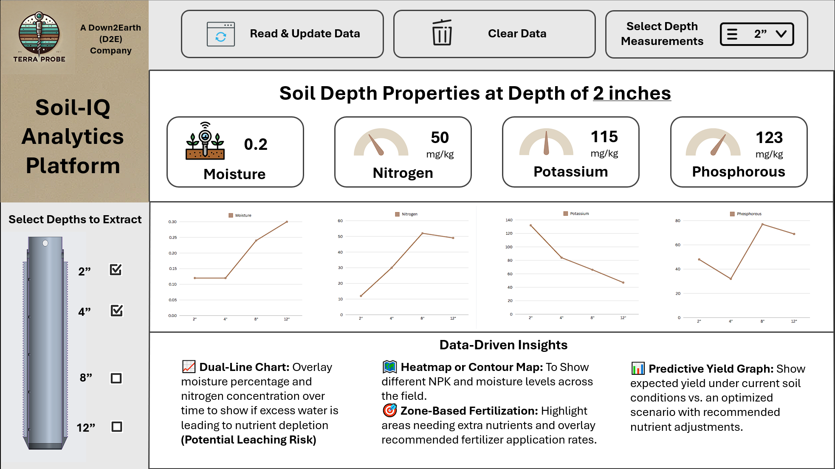

**Figure 8: Sample Dashboard Design**

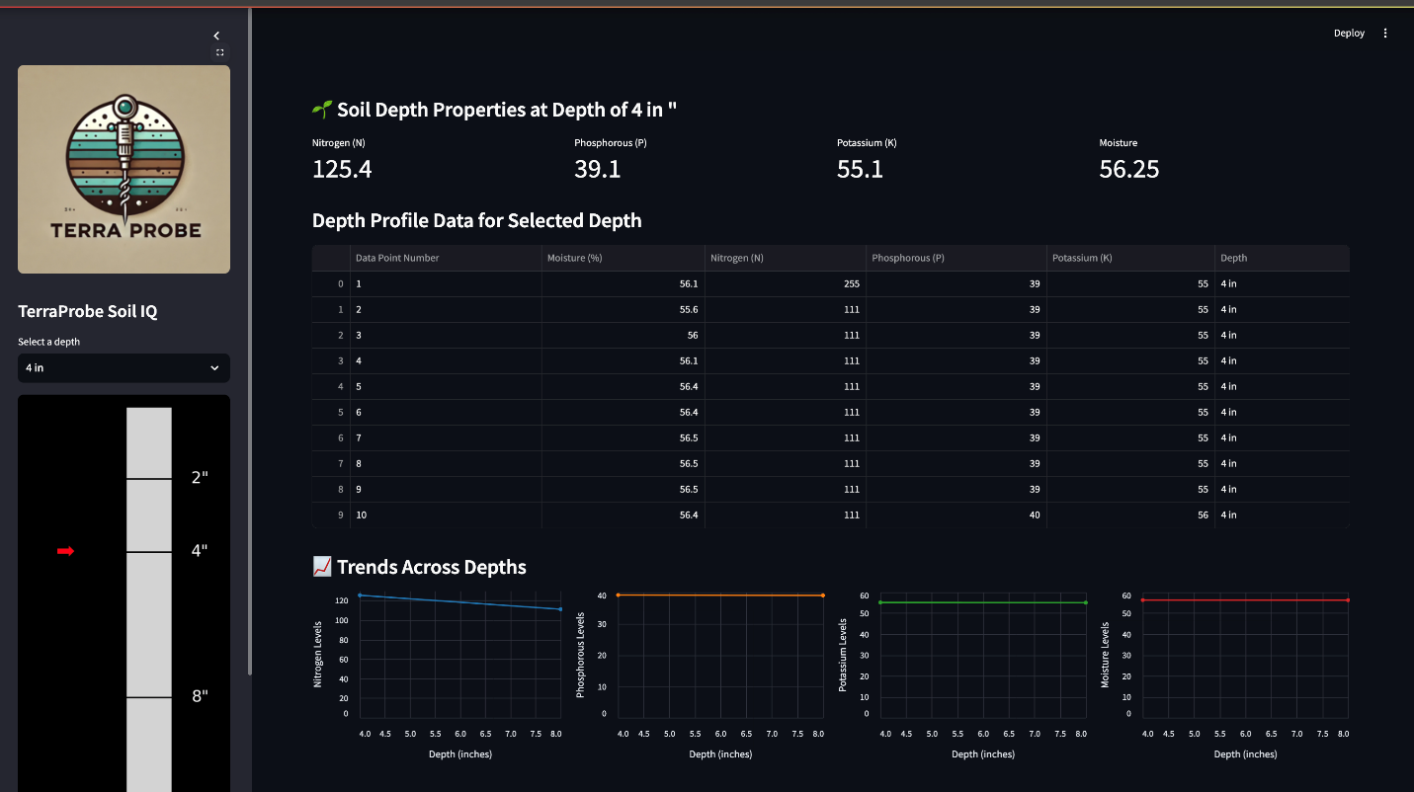

**Figure 9: TerraSoilIQ - Actual Dashboard**

# **Manufacturing and Assembly**

Many different manufacturing techniques were implemented to bring the TerraProbe prototype to life. TerraProbe is comprised of three subsystems: the base compartment, which holds the motors, gears, and electronic components; the payload, which holds the soil sample and has slits to allow for in-field probing; and the outer shell, which surrounds the payload and has gear racks that mesh with the pinions in the base compartment.

* 1. **Walls and Foot Pedals**

The walls and foot pedals were both made from UHMW plastic. This material was chosen as they can bear high loads while being light. However, they needed to be machined a specific way due to their material properties. They couldn’t be laser cut; hence we had to utilize a water Jet to cut out the general shape for both the walls and foot pedals. The CAM was for the parts was made in Fusion 360 and the part was machined from a 24” x 12” X 0.25” UHMW stock.

Not all features could be water jet, such as 8/32 and 3/48 holes for screws – as they were too small. Hence, we need to use the mill and hand tap the part to ensure proper threading. A combination of thorough holes (with countersinks) and tapped holes allowed us to create an easily assembled set of UHMW Walls. Holes were also machined in the bottom of the walls for 3/48 screws. The back wall of the UHMW need two square holes for the motor axle end and electronics to not interfere with the walls while the rest of the assembly stayed fixed.

A set of 4 holes (8/32) were manufactured for the foot pedals to install hinges. Since UHMW can be slippery, we added grip tape. Additionally, the screws for the hinges were also bolted down to ensure they wouldn’t strip from the foot pedals during operation hinges combined with the threaded holes on the bottom of the UHMW walls allowed us to easily affix the pieces onto the base plate.

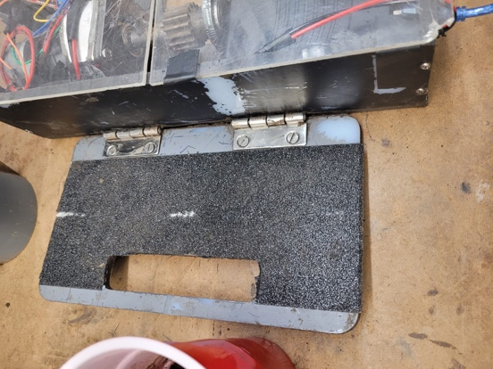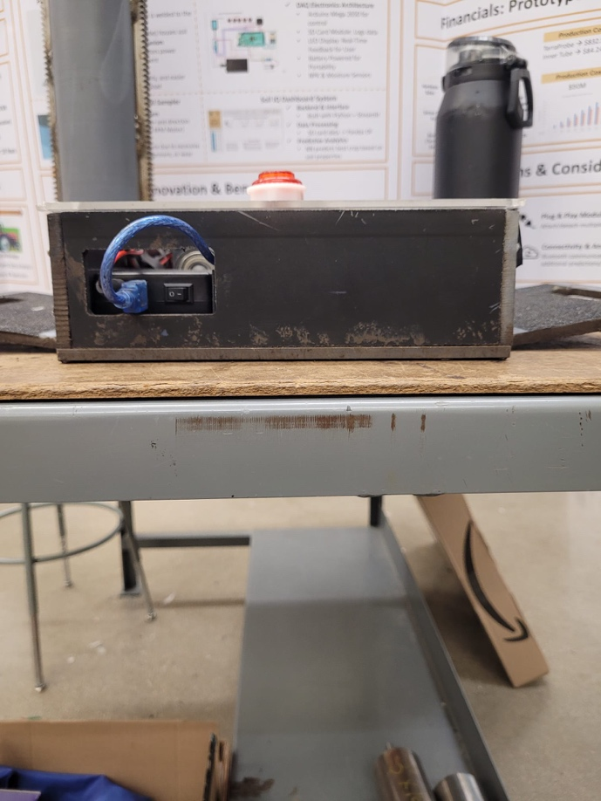

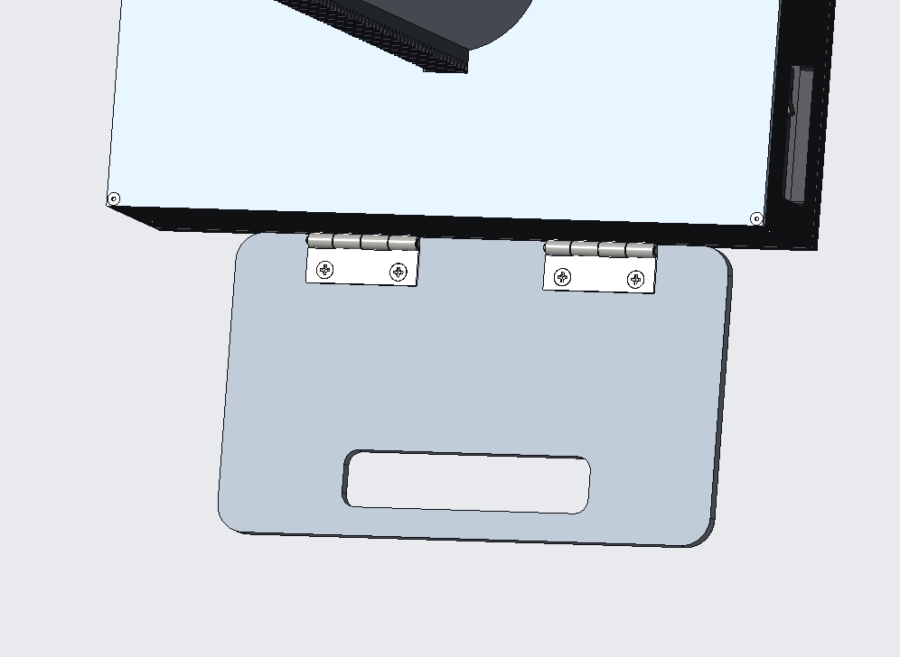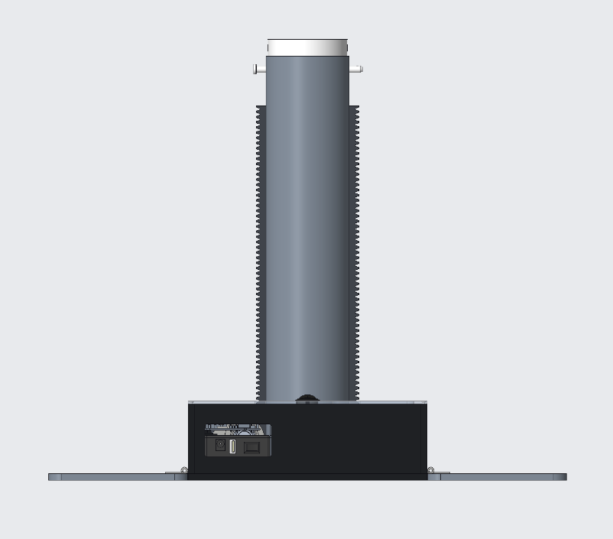

**Figure 10: CAD vs. Manufactured Walls & Foot Pedals**

* 1. **Base Plate and Mounts**

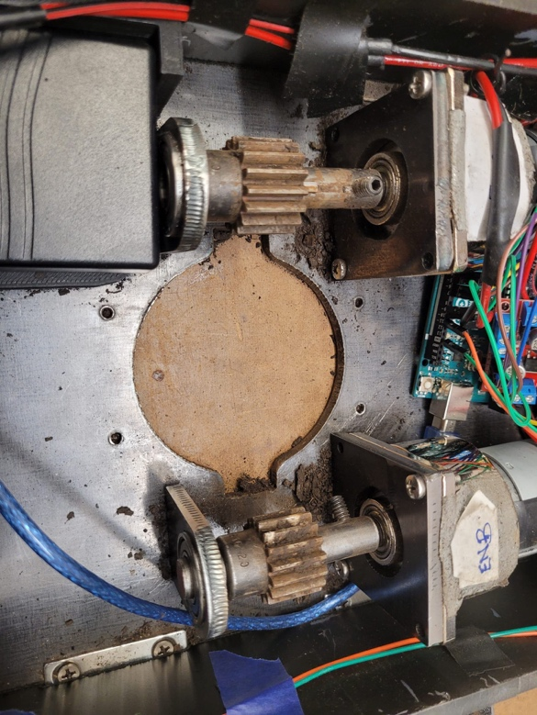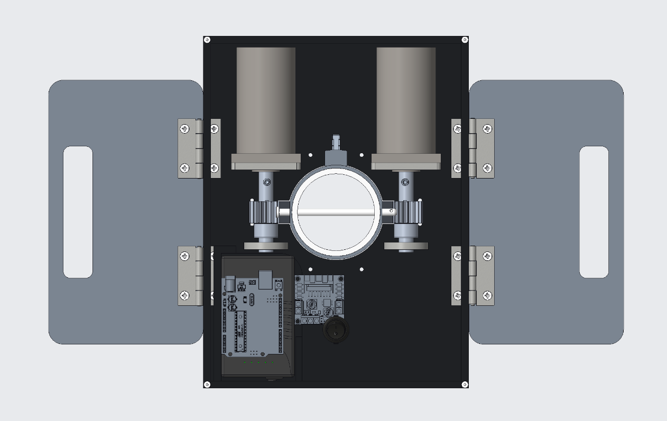The base plate, which is made of ¼" thick sheet metal, was cut to size on the laser cutter in the Purdue machine shop. Then holes were drilled and tapped into the base plate to accommodate foot pedal hinges, motor mounts, bearing mounts, and a 3D printed shell guide to stabilize the payload and outer shell. All burrs were removed from the plate to ensure the bolts could easily thread into the base plate. The motor mounts and bearing mounts were made in a similar way. They were laser cut from ¼” sheet metal and tapped to allow small screws to hold them to the base plate. An issue that occurred while laser cutting the sheet metal was that the metal heated to the point of melting, which led to small metallic bubbles forming on the edge of the part. To mitigate the bubbles, the parts were quickly removed from the cutting station after the operation. Lastly, the motor and bearing mounts were screwed perpendicular to the base plate using 8-32 countersink screws.

**Figure 11: CAD vs. Manufactured Base Plate / Mounts**

* 1. **Gear Axle**

The two gear axles began as a 1ft rod of ½" diameter 4140 alloy steel stock, which was then cut to 3” on the vertical bandsaw. These cylinders were then moved to the lathe where they were faced off and drilled to sheath the motor axles. A slight chamfer was added to both ends to remove burs. Then, the axles were transferred to the mill to drill and tap holes for a set screw that would hold the motor axle, which has a D-hole profile. Finally, a 1/8” set screw channel was cut using an end mill. When assembling the gear axle subassembly, the axle is slid onto the motor axle and tightened using a ¼-20 set screw. The opposing end of the axle is fit into a bearing, and the center of the axle is fixed to the pinion by means of a set screw.

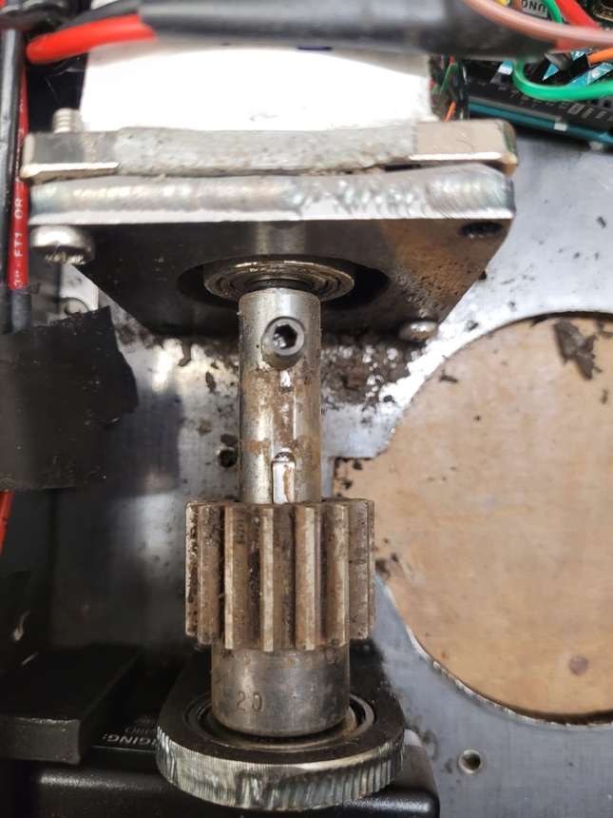

**Figure 12: CAD vs. Manufactured Gear Axle**

* 1. **Shell and Payload**

One of the most crucial components of the TerraProbe is the outer shell, which surrounds the payload and drives it into the soil using gear racks. The shell began as a 304 stainless steel tube with an outer diameter of 3.5”, thickness of ¼", and 2ft long. First, the tube was turned down to a diameter of 3.214” on the lathe. Then an internal snap ring groove was cut on the end of the tube. Next, the shell was transferred to the horizontal bandsaw and cut to 15.875” long. Then it was moved to the mill to drill a hole for the quick release pin at the top of the shell. Finally, a flat space was machined along the length of the shell to allow the racks to be welded to a flat surface. Both the racks and shell collars were welded to the outer shell, and luckily it caused nearly no warping.

The payload went through several stages of machining. The first payload we utilized was 3” OD and 0.0625” thick made of 304 stainless steels. While these were the required dimensions, it did not provide a sliding fit with the inner diameter of the shell. It was also too thin to machine the outer diameter using a lathe. Hence, we had to go with a thicker pipe – 3” OD and 0.1875” thickness A513 Carbon Steel – and tool it down 15-30 thousandths using a lathe in order to provide a sliding fit. This caused two major changes from the intended design:

* The product was heavier than designed
* The increased thickness meant that the friction exerted by the soil would greatly increase.

On this new stock, two 0.25” holes were drilled using a mill in for the quick release pins to be used – one hole for the pin to serve as a handlebar and the other to ensure the shell and payload stayed in unision during operation. Then, using an 3/8 end mill, four slits of 1.5” were manufactured along the length of the payload. These slits would serve as holes for the sensor probe (TerraPal) to pass through and contact the soil to collect data.One other slight change made was the addition of grip tape to the inner walls of the payload – this was to better hold onto the soil post drilling into the soil.

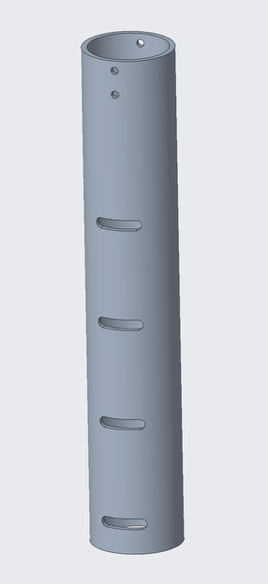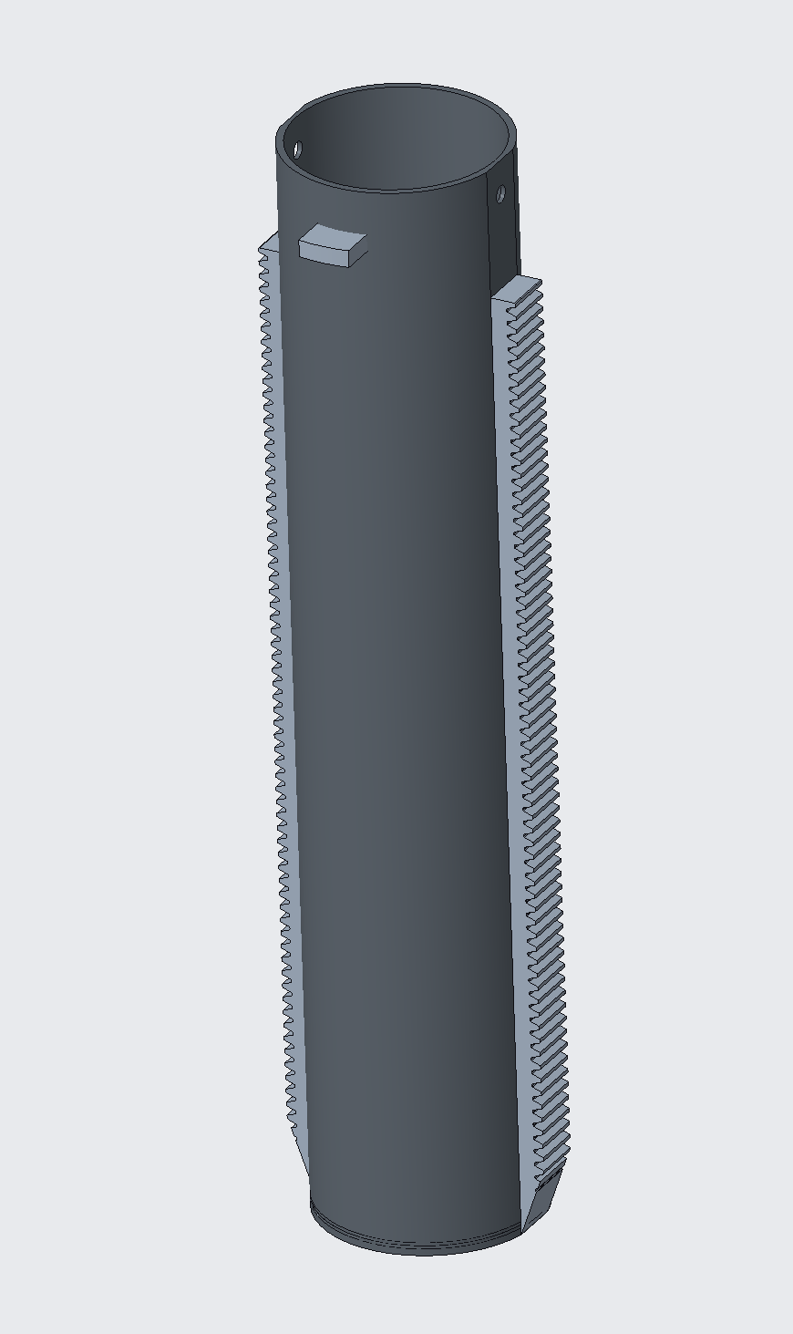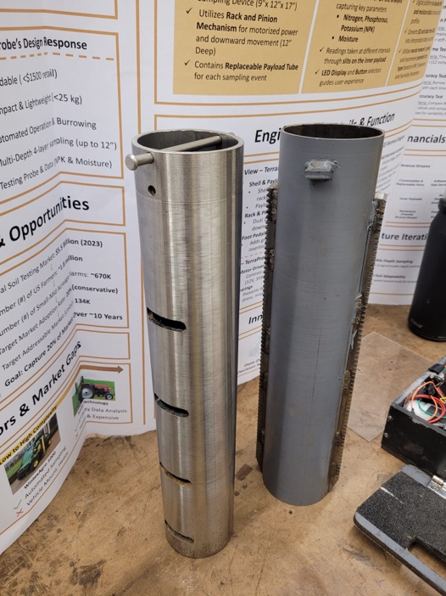

**Figure 13: CAD vs. Manufactured Shell & Payload**

* 1. **3D Printed Parts**

3D printing was utilized in two situations – when the parts don’t bear high load or their geometry is complex to hand manufacture. There was a total of 4 parts that were 3D print.

The Sensor probe (TerraPal) was printed in 3D. It bears no load and serves only as the container for the electronics – such as Arudino Mega, SD card Module, wiring and the NPK and moisture sensor. 3D printing proved to be the best as the wiring and electrical systems went through several iterations, allowing us to get multiple iterations of the casing.

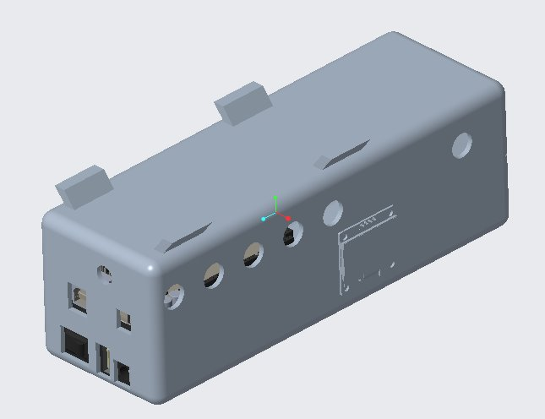 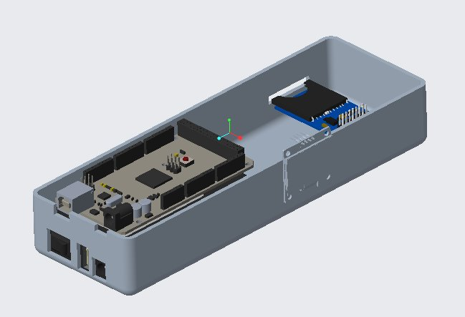

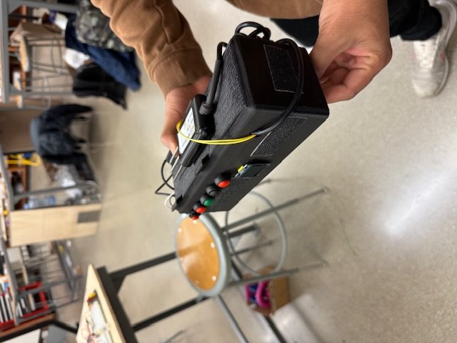

**Figure 12: CAD vs. Manufactured Sensor Probe Casing**

The shell guide was also 3D printed. This was since the geometry was complicated and there was no way to manufacture such shapes. Additionally, the guide only served as a supporting tool to ensure that the payload and shell go down straight – hence do not bear much load. Black 3D printed PLA, hence, would be an appropriate choice. Additionally, the 3D printing allowed us to run multiple iterations to get a better fit on the racks. However, eventually the final design didn’t end up using the shell guide as they often caused the racks and the gear to unmesh due to slight vibrations/interferences.

The brush and the battery mounts were 3D printed. They were small and non-load bearing components and had complex geometries – as we tried to minimize the space on the base plate taken by them while making them accessible during the testing phase.

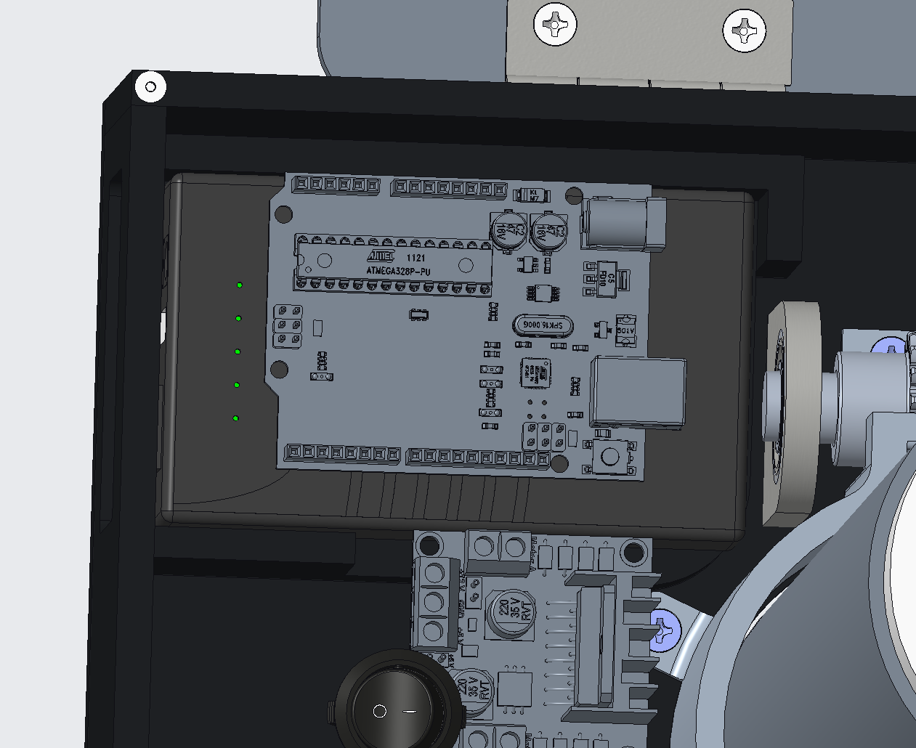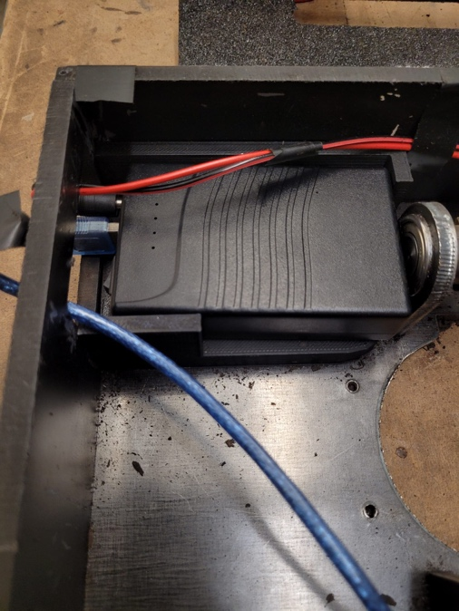

**Figure 13: CAD vs. Manufactured Battery Mount**

* 1. **Electronics – Motors**

The Motor Control Box serves as the key electrical components responsible for driving the rack and pinion system, providing adequate force to burrow through the soil. The system was made of two 12V, 30RPM DC gear motors based on mechanical analyses performed which showed that we required 35W power and 30RPM motor speed. The motors are controlled by a L298N Dual H-Bridge motor driver, programmed through an Arduino Uno microcontroller and powered by a 12V rechargeable battery. To enhance safety and usability, a switch was added to function as an e-stop (start/stop functionality) and a limit switch changed the motor direction to prevent over-travel once the maximum payload height was reached (Appendix A.3 – CAD Designs contain an electronics diagram).

To manufacture the motor control box, we assembled the Arduino, L298N motor drivers, and motors onto the metal base plate with designated zones for wiring and components. Motors were programmed for synchronized operation, and user controls like a switch and limit switch were integrated for easier operation. However, tight spacing, wiring fragility, and power supply inconsistencies created challenges that highlighted several areas for improvement.

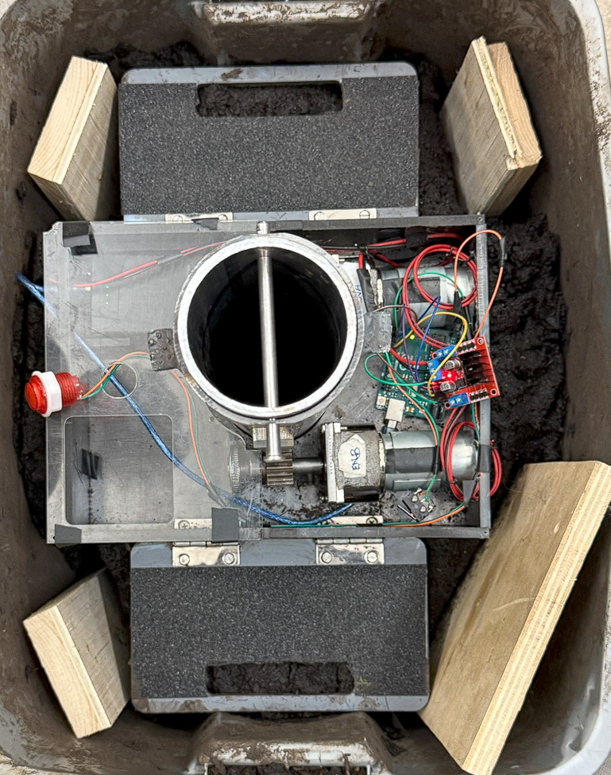

**Figure 14: Electronics Motor Control Sub-Assembly**

**What Worked Well:**

* Motors were synchronized through Arduino programming (Control of PWM), preventing tilting and mechanical issues
* E-stop and limit switch button worked as intended and assisted with soil burrowing

**What Didn’t Work Well:**

* Tight base plate spacing led to cramped wiring, requiring fragile solder joints that often broke
* The L298N motor drivers had sensitive, unreliable wire connections prone to disconnection
* Battery charge level caused inconsistent motor performance, revealing power delivery issues
* Motors operated below their rated speed (~22.5 RPM instead of 30 RPM), slowing soil penetration

To improve reliability and ease of manufacturing, future design iterations will consider increasing spacing, soldering wires directly to motor drivers, selecting more robust and higher-powered motors, and stabilizing power delivery. Additionally, we will be creating an electronics mount to hold the Arduino uno and motor driver to simplify wire management like the image below:

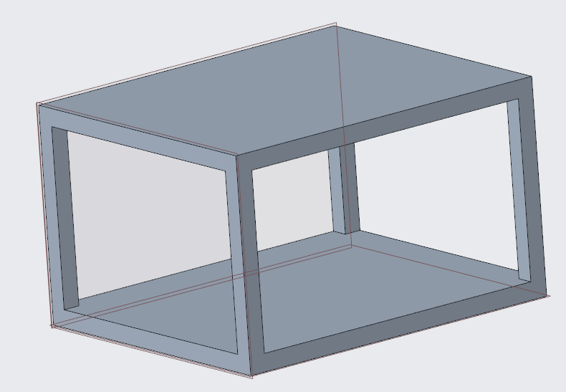

**Figure 15: Electronics Mount**

* 1. **Electronics – Data Acquisition System (DAQ)**

The Data Acquisition System records the sensor data onto an SD card for later analysis. During manufacturing, we focused on improving connection reliability and wire management by transitioning from a breadboard to a custom PCB setup. This helped organize the 5V and ground connections and eliminated a major source of loose wires.

To build the system, we soldered all 5V and ground connections onto a PCB, removing the need for a large breadboard and significantly improving stability. The SD card module was directly wired but remained sensitive; if wiring wasn't secure, the module sometimes failed to initialize and recognize the SD card. Another challenge we noticed during manufacturing was that the SD card slot could fall into the casing if not properly supported, requiring design improvements to better secure the module. Finally, because of side-exiting wires and buttons, the entire DAQ assembly didn't fit neatly into the rectangular slot we had originally designed in the TerraProbe lid.

**What Worked Well:**

* Soldering all 5V and ground connections onto a PCB improved wiring stability and organization.
* Arduino successfully logged NPK & Moisture data onto text file in SD card.

**What Didn’t Work Well:**

* SD card module wiring was fragile; poor connections led to initialization errors.
* The SD card slot wasn't securely held, causing it to slip into the case during handling.
* Side-exiting wires and buttons caused fitment issues with the TerraProbe lid insert.

**Future Improvements:**

* Design a mounting bracket to secure the SD card module inside the casing.
* Use right-angle connectors and reroute wires to better fit within the TerraProbe lid.
* Upgrading to a more robust SD card module with stronger onboard connection points.

# **Simulation-Analysis and Validation Testing**

To verify that TerraProbe meets its functional and design requirements, a series of validation tests were conducted. These tests were compared to simulations/analyses previously conducted used to determine force, motor selection, and other important components for the system. Key tests include motor calibration/performance, force testing, soil compactness vs. depth performance, motor RPM vs. depth burrowed, sensor precision measurements, and evaluation of the neural network’s loss and accuracy. Results from these tests helped understand shortcomings and design adjustments required for future design iterations. The premises of a few important tests have been mentioned below (Refer to Appendix A.3 for detailed analysis on all validation tests and software system tests).

* 1. **Simulated Force vs. Motor Performance**

The mechanical work required to run the device to reach the required depth needs to be considered. First a free body diagram was drawn to determine all the forces that would act on the payload.

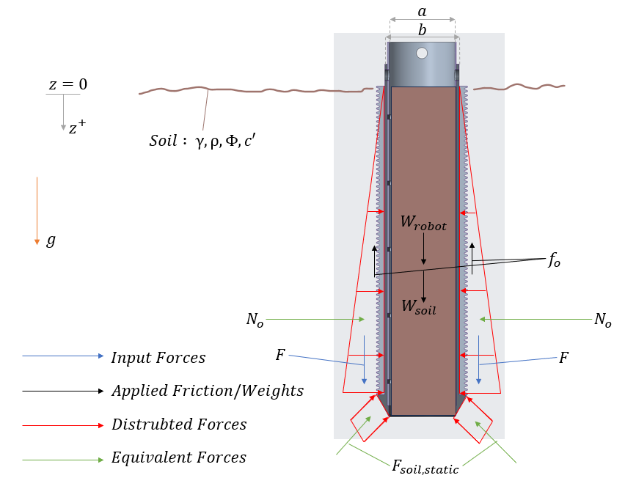

**Figure 16: Free Body Diagram**

Now the main forces are along the Z direction, and this will be the direction in which the rack will be provided force. The following Force balance equation can be used to determine the required force $F$.

$\sum{F_{z}=2F+f_{i}+W_{robot}+W_{soil}}-f_{o} -F_{soil_{static}}=\left(m+M\right)\ddot{z}$ $\left(1\right)$

Where $f_{i}$ is the internal frictional force, $W_{robot}$ is the weight of the robot, $W_{soil}$ is the weight of the soil collected, $f_{0}$ is the external frictional force, $F_{soil_{static}}$ force acting upwards modelled as a buoyancy force, $m$ is the mass of the soil collected, $M$ is the mass of the robot, and $\ddot{z}$ is the acceleration of the body

However, the frictional forces and desired motion profile are unknown. The external frictional forces were calculated according to the Rankine Theory (Earth Pressure Theory and Application, Purdue University, n.d). The internal friction force was considered negligible due to the incorporation of a lip as the soil enters the payload. Then a desired motion profile was created such that the robot would reach the required depth in 2 minutes. The calculated required force was 923.4 N (213.84 lbf) for stiff cohesive soils. (Refer to Appendix A.3 to see the calculations).

To provide the same force, a 35-watt, 12-volt motor needs to be run at 27.5 rpm (AGMA Calculation for the same can be seen in Appendix A.3 and exact motor identified in BOM). However, if the design needs to be implemented on a more cohesive soil, a gear box can be used to increase the gear ratio and hence the torque provided to the system.

Once the motors were acquired and the assembly was put together, the force provided by the motors was compared to what was needed to push the payload and shell sub-assembly manually. The force was determined using a weighing scale.

The first test was run with the base plate supported by and clamped to metal beams and only the racks and payload contacted the scale with the motors running. During this test we found that a maximum of **121 lbf** was provided and it reached a steady state of around **90 lbf**. The second test was to test the force that would be needed manually push down the payload sub assembly through the depth of the soil ~ 7-8 inches. Both tests collected around 6~7 inches of soil. Evidently the max motor force is much less than the calculated of 213.84 lbf on each rack – only a 1/4 of the required force was provided. This could have been due to a few reasons

* The motor bought did not match the specifications, not drawing enough power to provide required force.
* The battery provided inconsistent power over time as it discharges

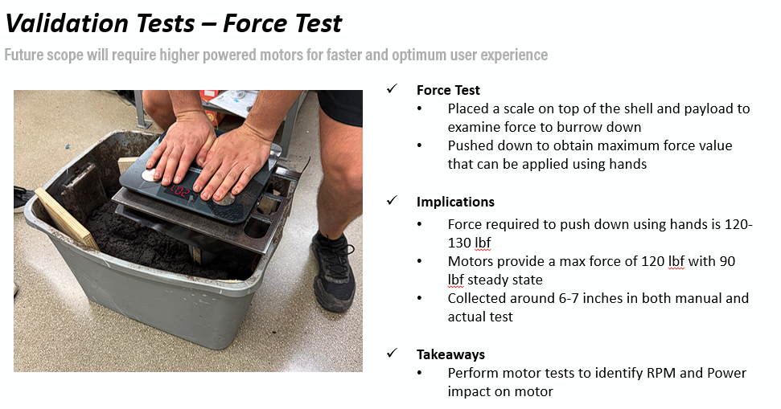

**Figure 17: Force Test on Soil**

* 1. **Soil Compactness vs. Depth Performance**

One of TerraProbe’s critical design requirements was to burrow through 12 inches of soil. The simulation and analysis to provide adequate force to burrow through 12 inches of soil was based on a mildly cohesive soil. However, soil conditions vary significantly in the real world, affecting burrowing performance. In order to simulate various soil types, we used 5174.8 cubic inches of dry garden soil and incrementally added ~128 oz of water (5% of the soil volume) per test cycle. At each iteration, we ran TerraProbe through the soil and measured the depth burrowed. The testing results showed that dry soil created high resistance which limited soil penetration. As the moisture levels increased, soil cohesion improved, enabling greater depth burrowing. At high moisture levels (384-512 oz of water), TerraProbe was successfully able to burrow ~6 inches of soil even with limited motor performance. This test highlighted the importance of soil moisture on TerraProbe’s performance and validated that while TerraProbe can meet its design requirements under moderately moist (cohesive) soil conditions, it will require additional motor performance to provide more force for drier soil conditions.

* 1. **Motor Depth Testing**

Given the force analysis required to burrow through the soil, motor performance is critical for delivering the force needed to burrow through the soil. In order to validate the motor behavior, we conducted a series of calibration tests comparing PWM input to RPM output. Although our selected motors were rated for 30 RPM at 12V. Testing revealed that the motors only achieve a steady state speed of ~22.5 RPM and ~5 second rise time when ran at max (100%) PWM. Additionally, the motors required ~30% PWM input just to overcome stiction and initiate motor movement. The team also conducted tests to analyze depth performance as RPM of motors. This indicated power delivery inconsistencies as the motors did not operate steadily at their rated 35W output. These findings highlight that the current motors underperform relative to design requirements, suggesting that higher RPM (50 RPM rated) or higher torque motors are necessary for future iterations. The figure below shows the motor response when ran at 100% PWM input.

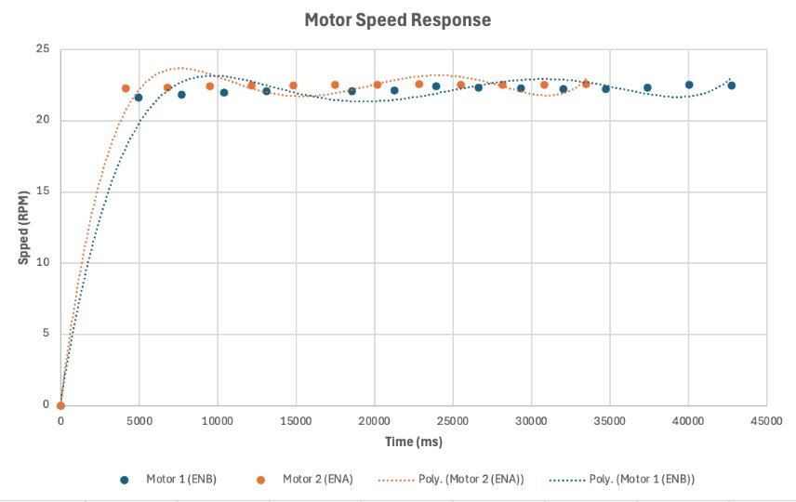

**Figure 18: Motor Speed Response over Time**

# **Failure Modes & Risk Management**

Failure modes and risk management for TerraProbe were evaluated through a combination of preemptive analysis and post-assembly experimental testing. The initial Failure Modes and Effects Analysis (FMEA) identified major risks including motor underperformance, soil resistance variability, power delivery inconsistencies, and mechanical durability concerns. Force and motor speed testing revealed that the motors delivered significantly less force (~90 lbf steady state) than the 213.84 lbf calculated for stiff cohesive soils, confirming the initial risk of inadequate torque output. Additionally, motor speed under real operating conditions was ~22.5 RPM instead of the rated 30 RPM, with significant stiction at low PWM inputs. Soil testing across different moisture levels showed that dry soil dramatically increased resistance, limiting penetration depth, while moderately moist soil allowed improved burrowing performance. Battery testing further highlighted inconsistent power delivery, causing fluctuations in motor performance and reduced system effectiveness. Mechanical assessments during soil penetration runs indicated that while no immediate failures occurred, improvements in vibration resistance, sealing, and joint reinforcement would be necessary for long-term deployment.

Based on these findings, several mitigation strategies were recommended to strengthen TerraProbe’s operational reliability. These include upgrading to higher-torque or higher-RPM motors, improving battery capacity and power management systems, reinforcing mechanical structures using hardened materials and vibration-resistant fasteners, and enhancing sealing protections against soil and moisture entry. Additionally, designing for worst-case dry soil scenarios and incorporating soil condition sensing were identified as critical for future iterations. Overall, the testing validated the original FMEA assessments, and the lessons learned through empirical data have been used to propose actionable improvements that would enable TerraProbe to better meet its burrowing and data collection goals under varied environmental conditions.

1. **Insights into Future Design Iteration**

The design overall functioned as intended, with some potential unsuccessful results for parameters set before in the concept design phase. While the system functionality was successful, there were key aspects revealed in several areas for improvement during the testing and validation phase. These insights will make the next design iterations more reliable, perform better, and have more ease of use in mass production and real-world applications.

The main critical limitation the team observed in the testing phase was the motor’s inability to provide torque to reach the full 12” sampling depth, especially in drier or compact soil. Force tests revealed that the motors only supplied 121 lbf at peak performance, whereas simulation calculations required around 213.64 lbf. To resolve this issue, an improvement that can take place is to replace the current 12V 30RPM DC gear motors with high torque alternatives, such as 12V 50RPM or in the range of 30-40 Nm. Also, a new battery should be used with higher capacity and lower internal resistance – ideally with a 24V lithium-ion battery to ensure consistent power and use a voltage regulator to supply 12V from this new battery. This upgrade will prevent voltage drops experienced during prolonged operations and maintain consistent RPM and torque output.

Another area of improvement that can be used is with the material chosen for certain applications. The UHMW plastics used for the foot pedals and walls, while lightweight, proved inadequate for the foot pedal application. Due to repetitive high-load conditions and not enough durability and down force provided by lightweight, the application was not up to par with the standards the team required. To resolve this, some improvements that can be made are to choose to explore switching to stainless steel or aluminum for structural components and foot pedals. This can increase durability without drastically increasing the weight of the product. This change can also improve user safety and overall functionality and robustness during the field test.

Another possible area of improvement is the data acquisition system (DAQ). While the functionality of this product was working as intended, there were problems raised with the wiring disconnections and poor fitting into the main mechanical enclosure. The Terra Pal casing could be additionally redesigned to be more ergonomic and handle a modular PCB layout. To resolve the wiring issue, a custom PCB with all the sensors can be made to reduce the space taken by wiring and better overall management of the product. This could also significantly reduce the size of the Terra Pal. Specifically, compact custom PCBs will replace the existing breadboard-style wiring, integrating the Arduino, SD card module, and RS485 communication into one board for greater electrical stability and manufacturability.

To summarize, the testing and validation portion of the design cycle provided valuable lessons for prototype testing and user handling. By upgrading the suggested choices above, mainly in the motor and power system, material choice, and electrical, the next iteration of the TerraProbe will be better equipped with a more functional design.

1. **Economic Analysis**

As we are planning the engineering and design feasibility of TerraProbe, it is also important to identify the market size and assess the economics of TerraProbe. TerraProbe is strategically positioned as an intermediate-tier product, bridging the gap between low-cost, manual soil sampling tools and high-end, fully automated solutions that are often prohibitively expensive for small to mid-sized farms. In the first year, TerraProbe’s focus will be entirely on setting up manufacturing and research & development (R&D) infrastructure, with an estimated investment of $10 million. During this period, no sales will be made as TerraProbe will refine its design, establish supply chains, and develop the proprietary analytics platform.

The U.S. market presents a significant opportunity, with approximately 671,000 small- to medium-sized farms that could benefit from soil burrowing and real-time soil analysis. Our long-term goal is to capture 20% of this market over ten years, equating to 134,200 units sold. In the first year of sales, we plan to introduce 5,000 units into the market and gradually scale up production, reaching an annual sales volume of approximately 35,000 units by Year 10. The TerraProbe device, including both the soil burrowing robot and testing probe, costs $862.77 to produce. Compared to CDR, the price increased due to the need for a 24V battery and 50 RPM motors which come at a higher cost. To remain competitive, we will sell the product at a 25% gross margin, pricing it at $1,100 per unit. However, the primary source of profitability will come from our service-based model of consumable inner tubes and analytics software to ensure customer retention and recurring revenue. To maximize long-term profitability, we will introduce two key recurring revenue streams: consumable inner tubes and an analytics subscription service. The consumable inner tubes, which store soil samples within the robot, cost $84.24 to manufacture and will be sold at a 50% gross margin for $130 per unit. Additionally, our analytics platform will provide farmers with actionable soil health insights for a one-time fee of $12 which grants them use of the software for 30 days, this allows farmers to prioritize buying the software during the tillage season. TerraProbe estimated an annual software/application maintenance cost of $100,000 which will largely be due to the processing power and data storage for the Neural Network. A breakdown of the estimated total revenue and cost has been projected for the first 10 years. While majority of the revenue still comes from selling the TerraProbe device, the consumable inner tubes and analytics software drives the profitability of the company.

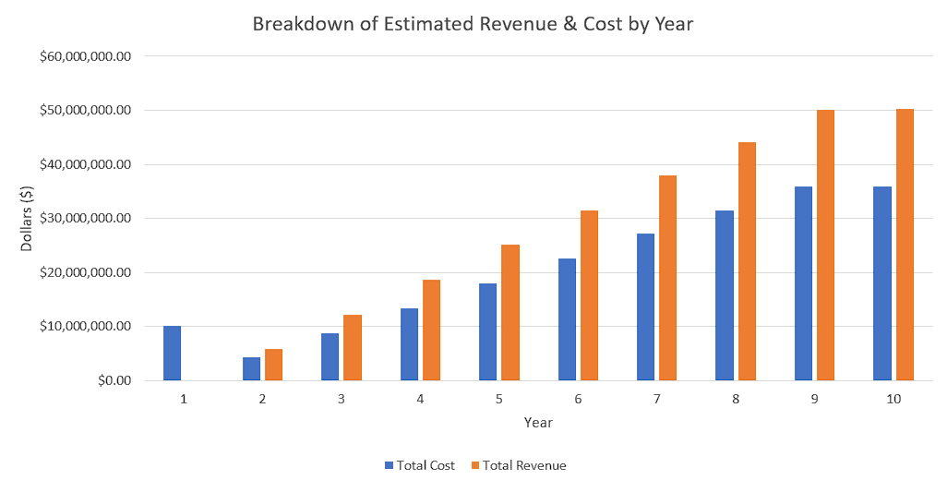

**Figure 19: 10-Year Revenue & Cost Projections**

At full market penetration, TerraProbe is projected to generate approximately $50 million in annual recurring revenue by Year 10, firmly establishing itself as a key player in the precision agriculture industry. TerraProbe projects to break even between Years 4 and 5 and the 10-year return on investment (ROI) is projected to be around 33%, demonstrating the financial sustainability of our business model. By offering a cost-effective yet highly advanced solution, TerraProbe is well-positioned to redefine real-time soil sampling for farmers seeking affordability, efficiency, and data-driven insights. (Refer to Appendix A.1 for more information).

# **Conclusion & Next Steps**

TerraProbe and its counterpart, TerraPal, successfully demonstrated the feasibility of compact automated soil sampling and analysis. The product was intended to be used for small to mid-sized farmers. Through an iterative design process and testing, the team has developed a system that integrates mechanical sampling with real-time nutrient (NPK), soil moisture, and predictive crop recommendations based on soil type and other factors. Some key accomplishments of this project were a modular rack and pinion soil burrowing system, an integrated NPK and moisture sensing prob, and a Python-based data dashboard providing crop recommendations.

While the current prototype achieved strong performance in portability, real-time data acquisition, and dashboard functionality, testing revealed several areas for improvement. Specifically, motor torque was insufficient for reaching deeper soil layers, wiring was prone to failure, and material selection for structural components like the foot pedals needs to be re-evaluated. These insights will guide our next design phase, where we plan to implement higher torque motors, redesign the electronics enclosure with a more compact PCB layout, and upgrade structural materials for durability.

As for the next phase of this project, there are some key aspects the team will follow for the project if it is continued in the future. One aspect is component upgrades: motors should be replaced with higher RPM, such as 50 RPM, and additionally, the power system should be improved to 24V and a voltage regulator to provide constant power to the motors. This will allow for better penetration through drier and more compact soil types. Manufacturing refinements: in terms of design, the baseplate could be expanded, cable wiring and management can be improved, and better cleaning and maintenance aspects can be added. Electronics and DAQ system enhancements: a PCB could be developed to reduce wiring constraints, and secure SD card housing, along with better cable management, can be made to improve the reliability of the electrical design. Lastly, Productization & Scaling: Batch testing can be done with small-scale manufacturing, and cost optimization and refinement of the analytics can be made to test the feasibility of large-scale production of this device.

With these improvements, the TerraProbe can be a better solution than current technology in the precision agricultural space. It brings lab-quality soil insights directly to the field in a portable, cost-effective, and easy-to-use solution.

# **APPENDIX**

# **A.1 - Project Management**

1. **Charter (Attached as Project_Charter_v2.xlsx)**

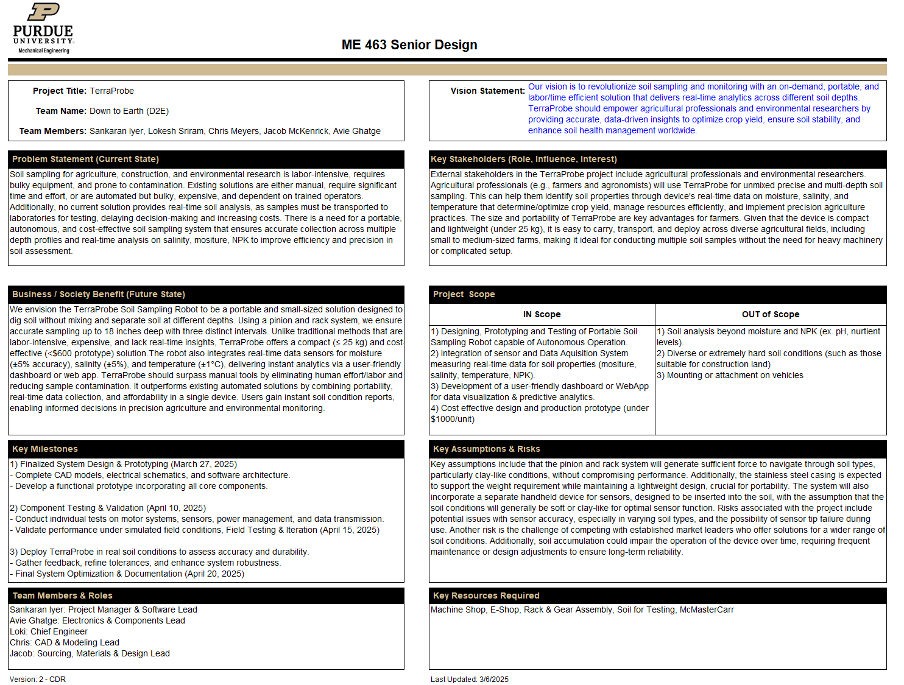

1. **Schedule (Attached as Project_Schedule_FDR.xlsx)**

**No modifications were made from CDR – Project was on schedule as intended.**

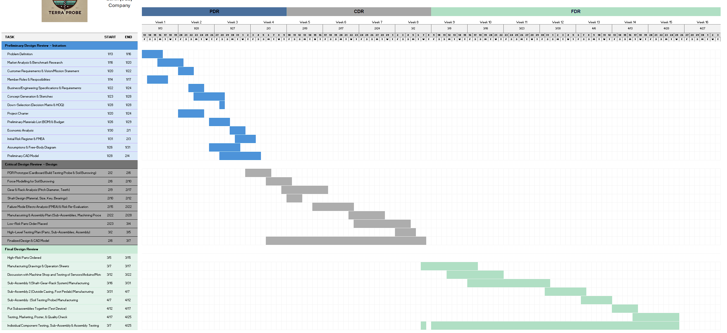

1. **Preliminary Budget**

**The preliminary budget can be found on Economic_Analysis_FDR.xlsx file attached. File was updated with 24 V battery and 50 RPM motor pricing, increasing the total product cost by roughly $30 to $862.77.**

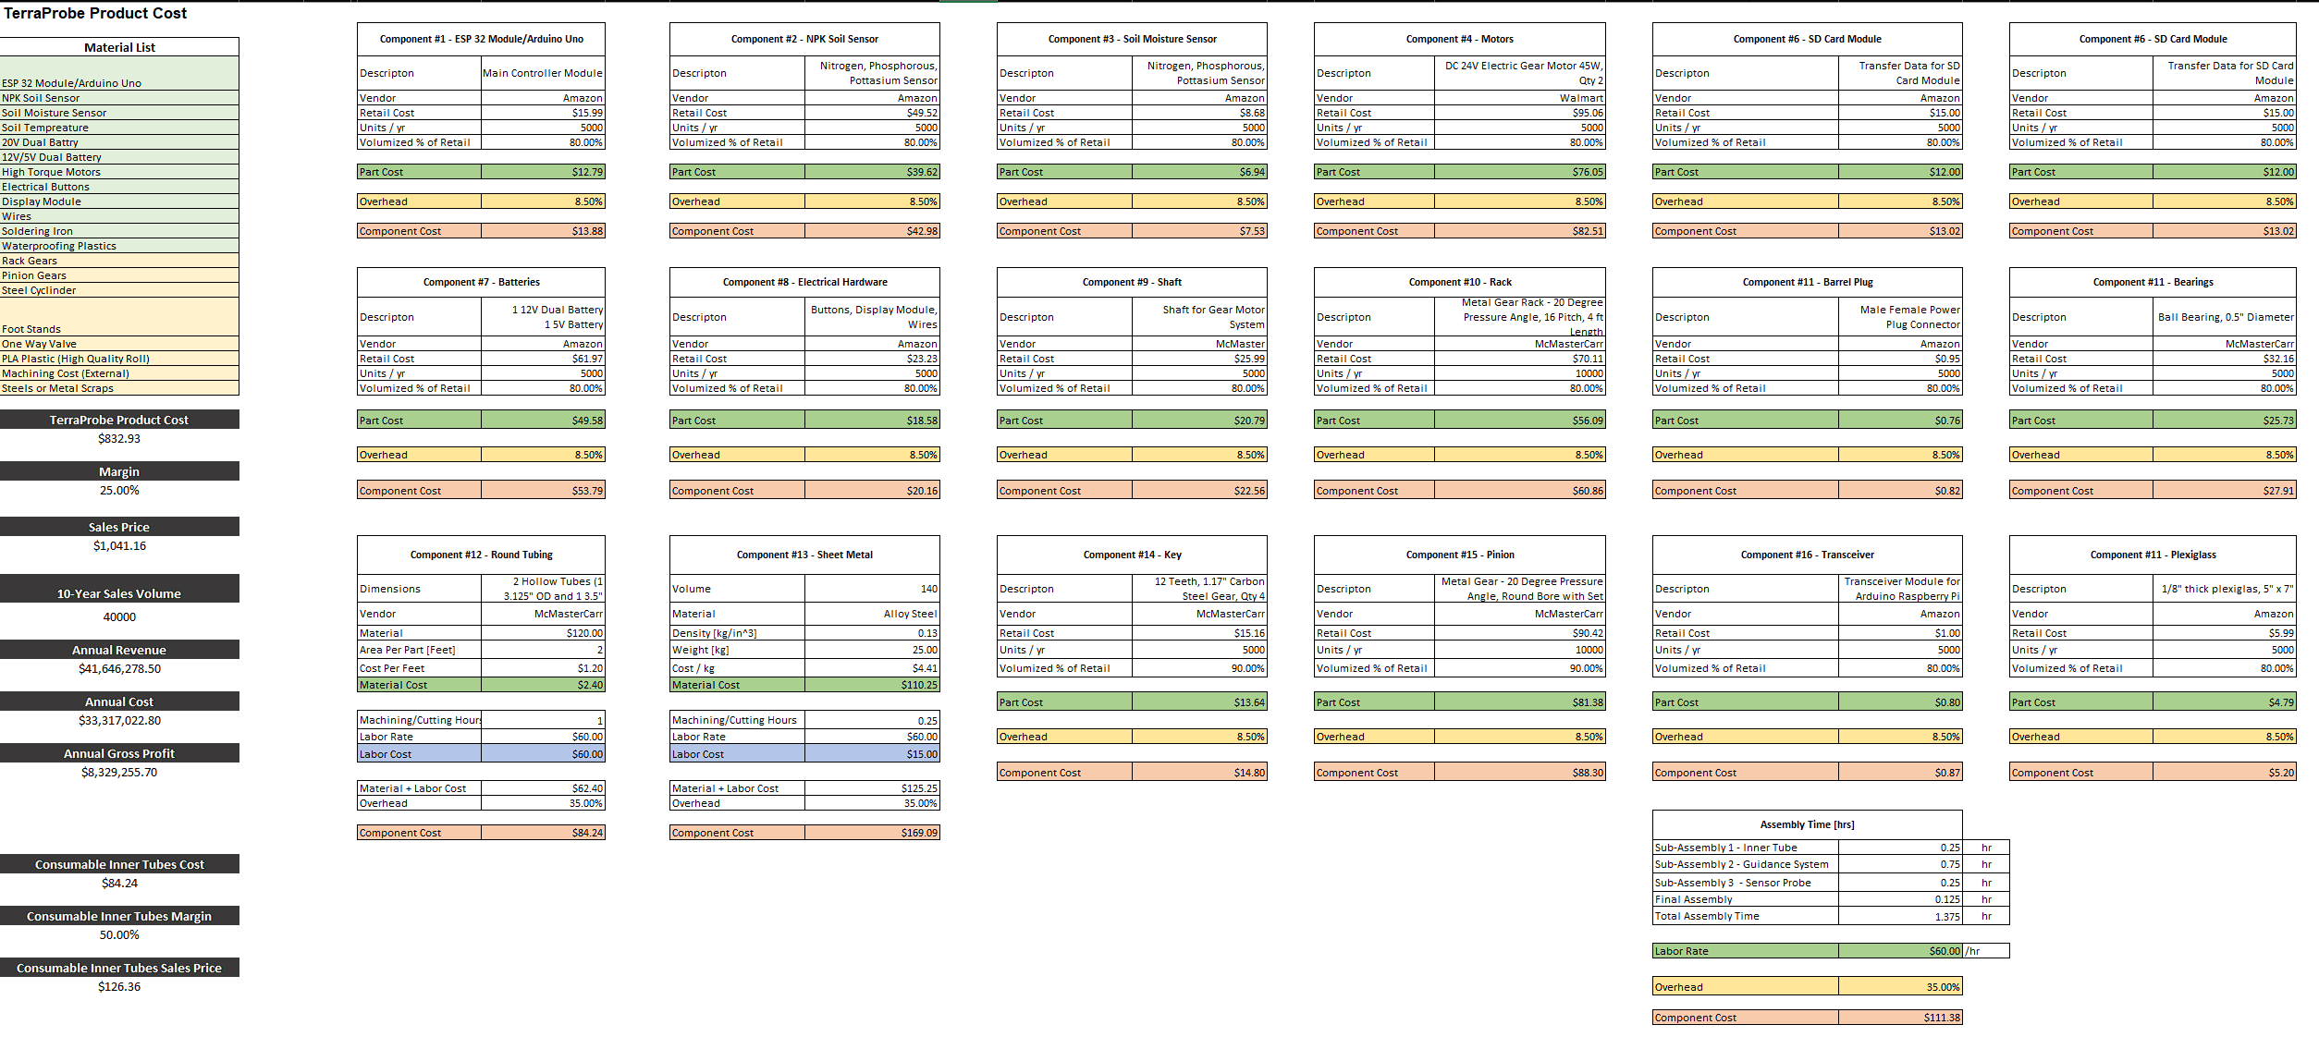

|  |  |  |  |
| --- | --- | --- | --- |
| **Total Product Cost** | **Margin** | **Sell Price** | **Annual Revenue (10-Year)** |
| **$862.77** | **25%** | **~$1100** | **$50M** |

1. **Risk Register**

The file Risk_Register_FDR.xlsx is attached to the document - No change was performed from CDR.

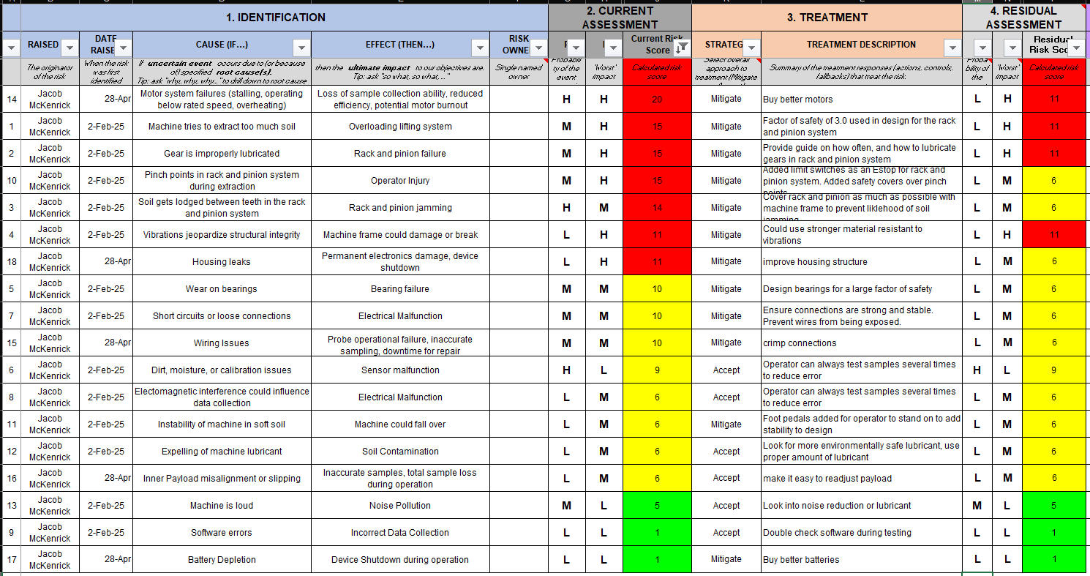

# **A.2 – Business / Marketing**

1. **Market Analysis**

The global soil testing market is experiencing significant growth, driven by increasing demand for precision agriculture and environmental monitoring. Valued at $5.5 billion in 2023, the market is projected expand with a compound annual growth rate (CAGR) of 10.4% from 2023 to 2030 (Grand View Research, 2023). This growth is supported by various factors, including the rising need for sustainable agriculture practices, increasing environmental concerns, and the adoption of advanced testing technologies. The market can be segmented into three primary target areas: agriculture, construction, and environmental research.



**Figure 20: Soil Testing Market Projection**

The agriculture sector shows promising growth potential, with the global smart agriculture market valued at USD 22.65 billion in 2023 and expected to grow at a compound annual growth rate (CAGR) of 13.7% from 2024 to 2030 (Grand View Research, 2023). This growth is driven by increasing automation in commercial greenhouses, implementation of controlled environment agriculture (CEA), and the adoption of advanced technologies such as IoT and AI in farming practices. Key players in this segment include AGCO Corporation, Deere & Company, and Trimble Inc., focusing on precision farming applications such as yield monitoring, field mapping, and irrigation management. The market is also seeing innovations in livestock monitoring, smart greenhouses, and the integration of technologies like drones, sensors, and data analytics to optimize agricultural processes and improve productivity.

In the construction sector, the geotechnical investigation market is valued at $5.22 billion annually in 2025 and expected to reach $8.65 by 2030 with a CAGR of 10.62% (Mordor Intelligence, 2023). Companies like Fugro, Geocisa, and AECOM are prominent in this space, addressing critical requirements such as foundation stability assessment, environmental impact evaluation, and site suitability analysis.

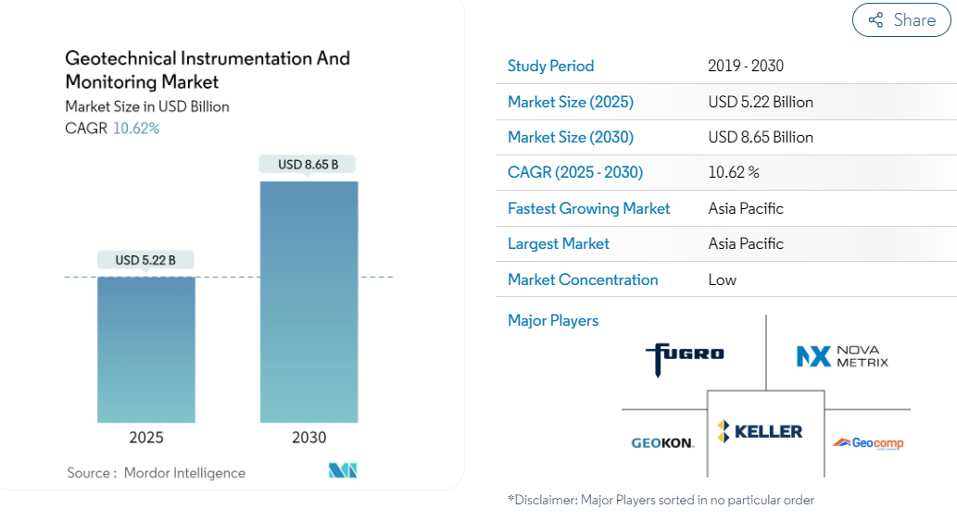

**Figure 21: Geotechnical Instrumentation and Monitoring Market**

The environmental research segment is driven by increasing climate change research and growing environmental monitoring programs, with organizations like NASA Earth Science Division, USGS, and the European Environment Agency leading efforts in soil carbon sequestration, contamination tracking, and ecosystem health monitoring (IPCC, 2022).

Despite the market's growth potential, there are several technological limitations and customer pain points to address in soil testing. Current soil testing methods often have limited accuracy due to sampling procedures, lack real-time data integration, and involve high operational complexities. Soil sampling can be time-consuming and requires careful consideration of factors such as sampling depth, pattern, and timing (University of Massachusetts Extension ,n.d.)

To enter this market effectively, a focus on the precision agriculture segment, particularly targeting small to medium-sized farms (50-500 acres), could be a strategic approach. Pricing strategies could include an initial unit price of $1500-$1800, complemented by sales of additional soil collection tubes. Distribution channels may include agricultural equipment dealers, online direct sales, and presence at agricultural technology conferences. Potential revenue streams for new entrants in this market include product sales, additional parts services, maintenance contracts, and custom research and development partnerships. To stand out in this competitive landscape, we plan to focus on developing a solution that offer real-time data collection, autonomous operation, compact and portable design, and lower costs compared to existing solutions.

However, potential challenges in market entry include technology adoption barriers, initial high development costs, regulatory compliance in different markets, and competition from established players. Stakeholders in this market ecosystem include internal entities like D2E, our team, and Purdue University professors, as well as external parties such as farmers, soil scientists, chemists, construction workers, land surveyors, and geotechnical engineers. Government agencies like the Department of Natural Resources, USDA, EPA, and Global Soil Partnership also play crucial roles in shaping the industry landscape (USDA Economic Research Service, 2023).

In conclusion, the soil testing market presents significant opportunities for growth and innovation, particularly in addressing current technological limitations and customer pain points. Companies that can develop cost-effective, efficient, and user-friendly soil testing solutions stand to capture a significant share of this expanding market.

**Customer Analysis and Market Strategy**

Current technological limitations in the field present several significant challenges, including a restricted depth range for sampling, inadequate real-time data integration capabilities, and high operational complexity that requires specialized training and expertise. These technical constraints have created substantial barriers to widespread adoption and efficient implementation.

Customer experience has been particularly impacted by the time-intensive nature of manual sampling, which requires 2-4 hours per acre to complete. This is further complicated by the high margin of error in traditional methods, with sampling errors ranging from 30-40%. Additionally, the substantial equipment costs have made it difficult for smaller operations to adopt these technologies, while the limited capacity for real-time data analysis prevents users from making timely, data-driven decisions in the field.

The initial target market focuses on the precision agriculture sector, specifically targeting small to medium-sized farms ranging from 50 to 500 acres. The pricing strategy has been structured to be competitive and accessible, with initial unit prices set between $600-1000, complemented by subscription-based data services for ongoing support and analysis.

The distribution strategy will utilize multiple channels to reach potential customers, including established agricultural equipment dealers, direct online sales platforms, and presence at agricultural technology conferences. This multi-channel approach ensures maximum market penetration and accessibility for customers.

Revenue generation will be diversified across several streams, including direct product sales, data subscription services priced between $50-200 per month, maintenance contracts for ongoing support, and custom research and development partnerships with agricultural institutions and technology companies. This diverse revenue model ensures sustainable growth while providing value at multiple customer touchpoints.

**Benchmark Research**

**Table 2: Customer Requirement Comparisons of Benchmark Products**

|  |  |  |  |
| --- | --- | --- | --- |
| **Customer Requirements** | [**AMS Soil Probes**](https://www.ams-samplers.com/soil-probes/?srsltid=AfmBOooCz73JXL5CJCZstnSxcL71dH0DrRpJWqvqxQZTRj4dp-7FCFa0&utm_source=chatgpt.com)  7/8" X 21" Soil Probe w/ Handle, 5/8" Thread | [**WintexAgro 1000 Automatic Soil Sampler**](https://wintexagro.com/products/wintex-1000/?utm_source=chatgpt.com)   | [**Amity Technology Soil Sampler**](https://www.amitytech.com/crop-management-tools/soil-samplers/)   |
| Portability & Lightweight Design | Weight: ~1 to 3 lbs  Length: ~33 inches  Portable | Weight: ~48 kg, 105 lbs  Length: | Weight: ~210 lbs  Length: 36” |
| Autonomous Operation | No, Manual Operation | Designed for vehicle mounting, portable with vehicle. Semi-automated sampling when mounted on vehicle | Designed for vehicle mounting, portable with vehicle. Semi-automated sampling when mounted on vehicle |
| Accurate Multi-Depth Soil Sampling | Up to 24” in 3” increments | Up to 30 cm or 11.8” | 24” to 48” |
| Integrated Real-Time Data Analysis | No | No | Yes, but might not be real-time |
| Cost-Effectiveness & Affordability | $100-150 | Price not publicly listed, reports mentioned $8000 | $3000-$6000 |
| Durability for Diverse environments | Yes, Stainless Steel construction | Yes Designed for different soil types and conditions. | Yes |
| Low Maintenance | Yes, Simple design with minimal maintenance needs | No, requires heavy maintenance, such as components that might need to be replaced and repaired rom time to time | Maybe, requires standard maintenance, such as components that might need to be replaced from time to time |
| Depth Accessibility | Yes | Yes, adjustable depth | Yes |
| Dashboard or WebApp for Analytics | No digital integration | No | Yes, partners with FARMQOA controller for cloud-based data and testing systems. |
| Differentiated Soil Depth Sampling | No, manual operation limits precise depth differentiation | No, multiple operations must be performed at the same location | Yes, higher level models available with multiple depth settings |

**Comparison of Benchmark Products to Terra Probe**

1. **Alignment with Problem Definition**:
   * Existing products partially address the need for efficient soil sampling and collection but fall short of delivering real-time analytics, multi-depth sampling, and soil mixing.
   * **AMS Soil Probes**: Simple manual tools, effective for basic sampling but lack depth accessibility, automation, and data integration capabilities.
   * **Wintex 1000**: Provides automation for shallow soil sampling but is limited to 30 cm depth and does not include real-time data analysis or visualization.
   * **Amity Technology Soil Sampler**: High-end automated sampling equipment capable of reaching greater depths (up to 48 inches) but lacks portability, affordability for small-scale users, and integrated real-time data analysis.
2. **Key Differentiators of Terra Probe:**
   1. **Portability**: While AMS soil probes are portable, the advanced automation of Terra Probe combined with portability (≤ 25 kg, compact design) makes it unique.
   2. **Automation**: Terra Probe integrates fully autonomous operations, bridging the gap between manual tools like AMS probes and semi-autonomous systems like Wintex 1000.
   3. **Depth Accessibility**: Unlike Wintex 1000’s shallow sampling limit, Terra Probe will achieve multi-depth sampling (up to 1 meter) with precise depth differentiation.
   4. **Real-Time Data Analysis**: None of the benchmark products feature integrated sensors for moisture, salinity, and temperature or real-time data visualization, a key strength of Terra Probe.
   5. **Cost-Effectiveness**: Terra Probe targets an affordable unit cost (prototype < $600) with low operational costs, making it accessible to small-scale users compared to Amity Technology and Wintex 1000.
   6. **User-Centric Design**: Terra Probe incorporates a dashboard/WebApp for advanced analytics, providing actionable insights to users in real time, an area entirely unaddressed by existing products.
3. **Summary**: The Terra Probe addresses critical gaps in existing soil sampling solutions by combining portability, affordability, autonomous multi-depth sampling, and real-time data analytics in a single, compact design. This positions Terra Probe as a transformative tool for agricultural professionals, environmental researchers, and construction firms to make data-driven decisions efficiently and sustainably.

**Patent Research**

Below are four patents researched, each different than our original idea:

The first patent, [US7827873B2,](https://patents.google.com/patent/US7827873B2/en?q=(soil+collection)&oq=soil+collection&page=1) is a soil sampling apparatus that also uses a punching method like the TerraProbe, however, this patent is a device that is attached to a tractor. While this patent can collect several samples, it involves owning heavy machinery already.

The second patent, [CN110470507B,](https://patents.google.com/patent/CN110470507B/en?q=(soil+punch)&oq=soil+punch) is like the WintexAgro mentioned in the previous section, as a cart that collects soil. This patent aims to be able to collect soil samples while being mobile. This device uses wheels on a cart as a method of mobility, whereas our design uses its lightweight design to ensure mobility.

The third patent, [EP1895090B1,](https://patents.google.com/patent/EP1895090B1/en?q=(soil+punch)&oq=soil+punch) is a patent for a method for creating a hole in the ground. This patent uses a bore similar to an augur to drill, whereas our method used a rack and pinion system.

Finally, patent [US11076525B2](https://patents.google.com/patent/US11076525B2/en?q=(soil+punch)&oq=soil+punch) is a self-propelled seed planter. This seed planter penetrates the ground using a spring. This seed planter also uses wheels for mobility like the second patent researched. The TerraProbe is different than this design in both ways by using a rack and pinion system and lightweight materials.

1. **Value Propositions & Economic Analysis**

The product's unique selling points center on several key innovations that address current market gaps. Its ability to collect data in real-time represents a significant advancement over traditional methods, while its autonomous operation capability reduces labor requirements and human error. The design emphasizes compactness and portability, making it easily transportable between locations and suitable for various field conditions. These features are offered at a lower price point than existing solutions, making advanced soil analysis more accessible to a broader range of users.

However, several potential challenges need to be carefully considered and addressed. The agricultural sector traditionally faces technology adoption barriers, particularly among established farming operations with existing methodologies. The development phase requires substantial initial investment to ensure product reliability and effectiveness. Additionally, navigating regulatory compliance across different markets presents complexity, particularly regarding autonomous operation and data collection standards. The presence of established players in the market with strong brand recognition and existing customer relationships poses another significant challenge to market entry and adoption.

An economic analysis excel document is attached which provides a detailed economic analysis of TerraProbe, including cost breakdown, revenue projections, and return on investment (ROI). The findings highlight the financial feasibility and long-term benefits of implementing TerraProbe in real-time environmental data collection.

1. Cost Breakdown
   1. The total development and operational costs for TerraProbe were estimated and distributed as follows (Detailed breakdown and description of each part can be found on the attached file Economic_Analysis_CDR.xlsx):
      1. Hardware Costs: Approximately $862.77 per unit, covering mechanical components, sensors, microcontrollers, and communication modules.
      2. Manufacturing & Assembly: Labor costs of $60/hr cover machining, cutting, and assembly. Overheads range from 8.5% to 35%, accounting for sourcing, supply chain, plant operations, and marketing.
      3. Operational Expenses: Initial factory and R&D setup costs are estimated at $10 million, with annual software maintenance expenses of $100,000.
2. Revenue Model & Market Viability
   1. a. Based on market analysis and projected demand, TerraProbe is expected to generate revenue through multiple streams:
      1. Hardware Sales: Units will be sold at $1,100 per device with a 25% gross margin, keeping prices competitive to encourage adoption.
      2. Consumable Inner Tubes: These replaceable soil storage units, costing $84.24 to produce, will be sold at $130 per unit with a 50% gross margin.
      3. Analytics One-Time Fee: Farmers can access real-time soil health data for a $12 one-time fee that will grant them a 30 day access to be used for tillage seasons.
   2. b. Sales Growth & Market Capture:
      1. The U.S. has 671,000 small to medium-sized farms. We aim to capture 20% of this market (134,200 units) over 10 years.
      2. No sales will occur in the first year due to setup and R&D. In Year 2, 5,000 units will be sold, increasing incrementally to 35,000 units annually by Year 10.

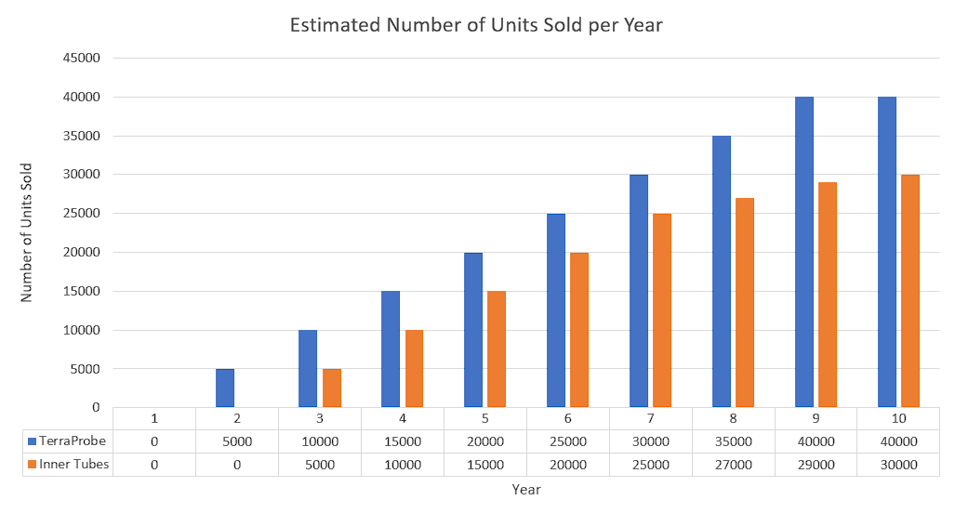

**Figure 22: 10-Year Projection of Units Sold**

* 1. Cost Savings & Efficiency Gains:
     1. Bulk purchasing of components is expected to reduce costs by 10% over time (The following figures below illustrate annual revenue, cost breakdowns, and expected profits)

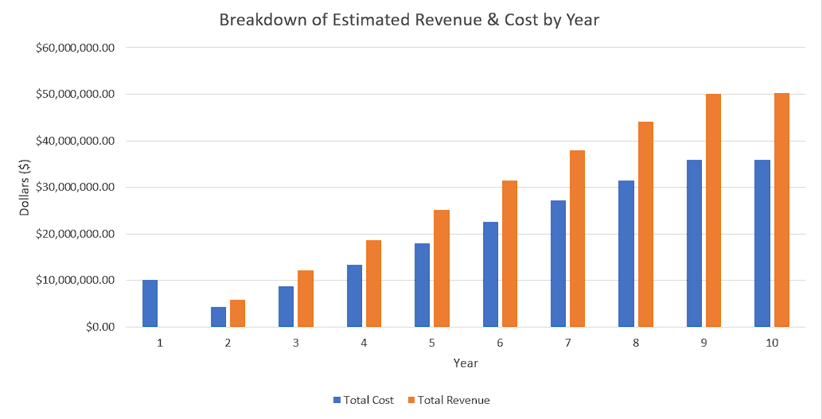

**Figure 23: 10-Year Projection of Total Revenue & Cost**

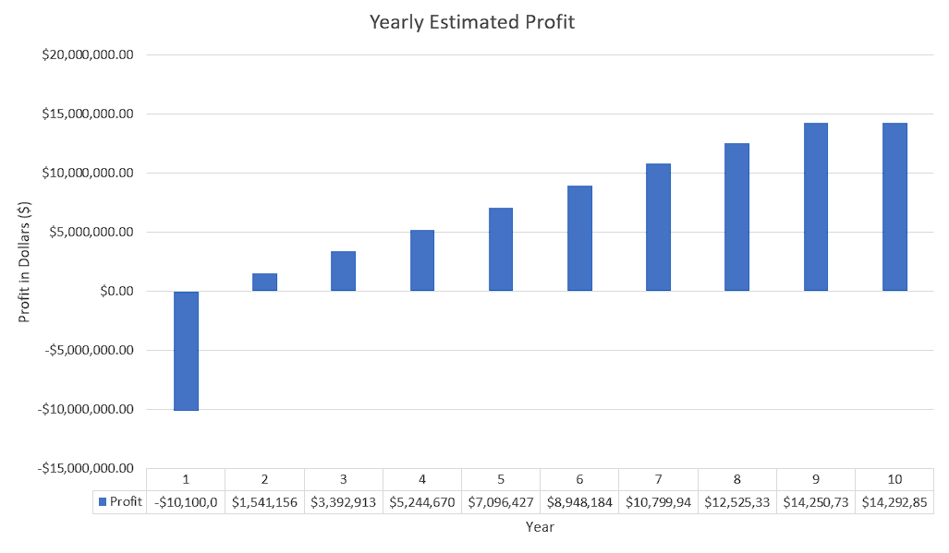

**Figure 24: 10-Year Projection of Yearly Profit**

1. Return on Investment (ROI) & Payback Period
   1. Breakeven Time: We estimate a breakeven point between Years 4 and 5, where revenue offsets the initial $10 million investment.
   2. Projected ROI: By Year 10, the return on investment is expected to reach 33%, with recurring revenue from consumables and subscriptions playing a crucial role in long-term profitability.
   3. This model, based on conservative estimates, presents strong financial sustainability with additional potential for market expansion beyond the projected 134,200 units.

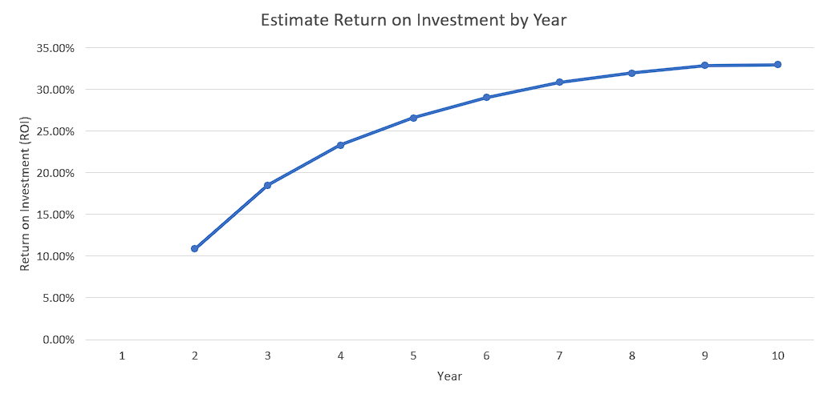

**Figure 25: 10-Year Projection of Return-on-Investment (ROI)**

# **A.3 – Design Process**

1. **Engineering Requirements & Constrains**

**Product Goals:**

* Deployment: Carried and placed at the desired location.
* Operation: Burrows autonomously to target depths, collects samples, and analyzes properties in real time.
* Output: Provides instant soil condition reports via an integrated app or display.

**Customer Requirements (CRs):**

* Portable and lightweight design
* Operates autonomously with minimal supervision.
* Accurate multi-depth soil sampling.
* Integrated real-time data analysis: Moisture, Salinity, Temperature sensors
* Cost-effective and affordable
* Durable for diverse environments (terrestrial and extraterrestrial).
* Low Maintenance (cleaning and storage features)
* Access 1 meter in depth
* Differentiate between multiple soil depths (at least 3 intervals)
* Dashboard or WebApp for Advanced Analytics
* Autonomous operation

**Engineering Requirements (ERs):**

1) Portability and Lightweight Design:

* Total weight ≤ 25 kg to ensure portability and ease of handling.
* Dimensions not exceeding 23” W x 20” D x 14” H for easy transport and storage.

2) Autonomous Operation:

* Capable of operating autonomously with minimal human intervention for at least 2 hours of continuous operation.

3) Accurate Multi-Depth Soil Sampling:

* Ability to burrow and collect soil samples up to a depth of 0.5 meter ± 0.05 m.
* Sampling accuracy of ≥ 85% for soil retrieval across different depths.

4) Integrated Real-Time Data Analysis:

* Sensors capable of measuring:
  1. Moisture: Accuracy of ±5%.
  2. Salinity: Accuracy of ±5%.
  3. Temperature: Accuracy of ±1°C.
* Data processing and visualization in under 30 seconds via integrated software.

5) Cost-Effectiveness and Affordability:

* Prototype development cost not exceeding $600 per unit.
* Operational cost of <$1 per sample collected.

6) Durability for Diverse Environments:

* Operable in temperatures ranging from 0°C to 50°C.
* Water-resistant and capable of functioning in soils with varying moisture levels (0-100% saturation).

7) Low Maintenance:

* Designed for easy cleaning, with removable and washable parts.
* Minimal storage requirements, with maintenance intervals >100 hours of operation.

8) Depth Accessibility:

* Ability to distinguish between and collect samples from at least three distinct depths (e.g., 0-30 cm, 30-70 cm, 70-100 cm).

9) Dashboard or WebApp for Advanced Analytics:

* Provides a user-friendly interface for viewing real-time and historical data.
* Compatibility with mobile and desktop devices using industry-standard software protocols.

10) Differentiated Soil Depth Sampling:

* Mechanism to analyze and record soil properties (moisture, salinity, temperature) for individual depth intervals with ≤10% error in differentiation.

11) Autonomous Operation:

* Fully automated navigation, sampling, and data transmission, requiring no more than 5 minutes of setup time.

The development of TerraProbe focuses on addressing key challenges faced by the current benchmark models. TerraProbe aims to overcome these limitations by ensuring affordability, maintaining product development costs and sale prices under $1000 to allow for competitive market pricing. Additionally, the device is designed to be lightweight, weighing no more than 25 kg, and compact, with maximum dimensions of 23” W x 20” D x 14” H, ensuring easy transportation and storage. Autonomous operation is a key feature, allowing users to collect soil samples effortlessly, with the ability to extract up to 18 inches of soil while integrating real-time analysis for moisture, salinity, and temperature. The system is engineered to operate in diverse environmental conditions, functioning effectively between 0°C and 50°C, while maintaining a low-maintenance design that requires servicing only after 100 hours of operation. A user-friendly dashboard or web application is also integrated to provide real-time data visualization on mobile and desktop devices. A few customer requirements, engineering requirements, and respective importance ratings are laid out in Table 3 below. (Refer to Appendix A.3 for more information on customer requirements.)

**Table 3: Translating Customer Requirements to Engineering Requirements**

|  |  |  |
| --- | --- | --- |
| Customer Requirement | Engineering Requirement | Importance Rating (1-5) |
| Safety | Automatic shut-off if the device malfunctions or detects an obstacle | 5 |
| Portability & Lightweight Design | Device must be < 25 kg and compact to ensure portability | 5 |
| Autonomous Operation | Must operate and collect soil without manual force for at least 2 hours of continuous operation | 3 |
| Accurate Multi-Depth Soil Sampling | Collect up to 18” of soil profile without mixing | 5 |
| Integrated Real-Time Data Analysis | Equipped with sensors for moisture (±5%), salinity (±5%), and temperature (±1°C), with data processed in under 30 seconds. | 3 |
| Cost-Effective and Affordable | Prototype development costs $600-1000 per unit, Sell Price Under $1500 | 4 |
| Durable for Diverse Environments | Operable between 0°C and 50°C, Water-Resistant | 4 |
| Low Maintenance | Maintenance required every 100 hours of operation | 3 |
| Depth Accessibility | Can collect soil samples from at least four depths: 0-2 in, 2-4 in, 4-8 in, 8-12 in. | 5 |

**Target vs. Actual Functional Performance Summary**

The TerraProbe prototype demonstrated strong alignment with several initial design targets while also revealing areas for improvement based on real-world testing. In terms of portability, the system exceeded expectations, weighing only 11.8 kg and maintaining a compact form factor (9” x 12” x 16.5”), making it highly field-deployable for small to mid-sized farming operations. Motorized operation was achieved; however, the current design still requires user supervision and careful setup to ensure reliable functioning, indicating an opportunity for further automation and robustness in future iterations.

The sampling mechanism partially met the depth accessibility targets, successfully retrieving distinct samples from the 0–2 inch and 2–4 inch layers. However, it struggled to achieve the full 12-inch depth goal, reaching only 6.5 inches in most tests. This limitation was primarily due to insufficient motor torque and power delivery, with the motors achieving a maximum steady-state speed of ~22.5 RPM and 120 lbf. force, falling short of the 30 RPM and 400 lbf. specifications originally targeted. This constraint also limited the system's ability to penetrate through drier, more compact soils effectively.

On the data acquisition front, TerraProbe performed very well. The integrated NPK and moisture sensors captured soil nutrient information as intended, and the machine learning model driving crop recommendations achieved 92.2% accuracy—exceeding the industry-standard benchmark of 85%. The Python-based dashboard provided an intuitive, interactive user experience for farmers to visualize soil health and crop recommendations in real time.

Finally, from a cost perspective, prototype development stayed within the targeted $600–$1000 range, thought on the higher end. However, a final estimated sell price was still very affordable and would be refined further through future scaling and manufacturing optimization studies. Overall, these results validate the feasibility of TerraProbe’s approach and highlight clear engineering directions for the next phase of development.

**Table 4: Comparison of Target vs. Actual Functional Performance**

|  |  |  |
| --- | --- | --- |
| **Requirement** | **Target** | **Actual** |
| Portability | < 25 kg, compact | 11.8 kg, 9” x 12” x 16.5” |
| Motorized Operation | Run independently without user effort | Has Motorized Operation but requires user supervision and careful assembly |
| Auger/Core Sampling Mechanism | Sample down to 12 inches | Sample down to 6.5 inches |
| Depth Accessibility | Distinct samples from 0-2 in, 2-4 in, 4-8 in, 8-12 in | Distinct samples obtained from 0-2 in, 2-4 in |
| Soil Type & Compactness | Devices should be burrowed through different levels of soil compactness | Easily burrows through cohesive soil but not dry soil |
| Motor Control | Provide a minimum of 30 RPM force and 400 lbf. | Provides ~22.5 RPM and 120 lbf. max Force |
| NPK Data Capture | Read Values for Nitrogen, Phosphorous, Potassium | Functions as intended and captures moisture as well |
| Dashboard & Crop Recommendation | >85% Model Performance Accuracy and Dashboard Visualization | 92.2% Model Accuracy and Interactive User Dashboard Presented |
| Cost Efficiency | Prototype Development Cost from $600-1000, with sell price <$1500 | Prototype Development cost |

1. **CAD**

Note: Manufacturing & Welding Drawings are attached at the end of the section

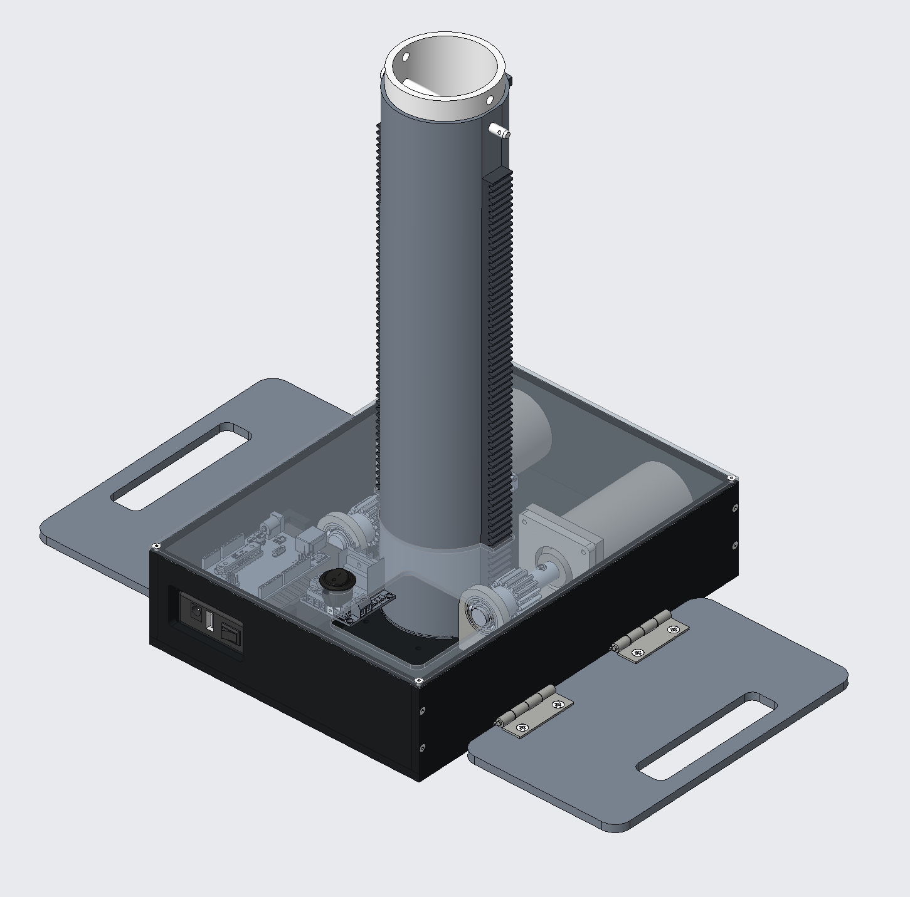

**Figure 26: TerraProbe Isometric View**



**Figure 27: TerraProbe Front View**

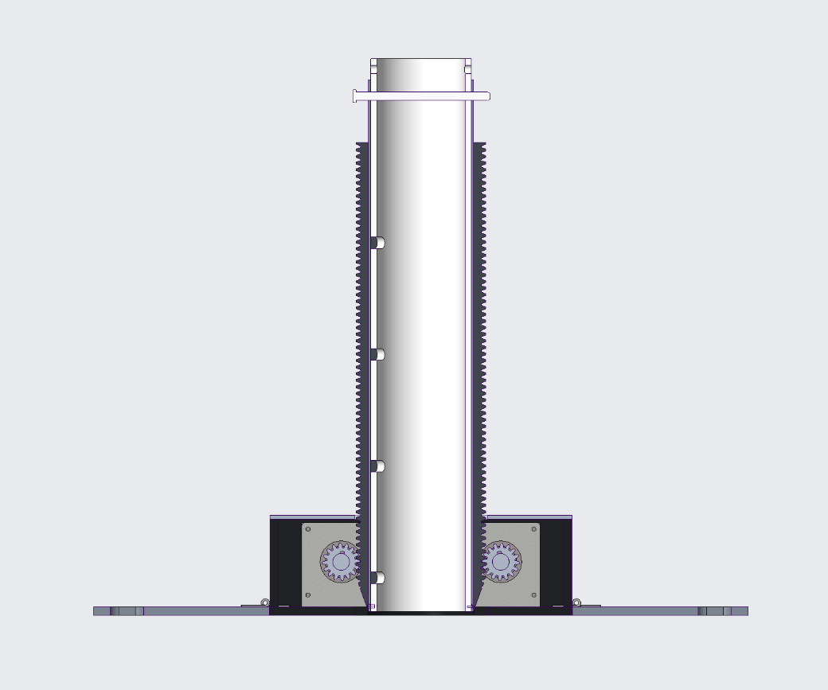

**Figure 28: TerraProbe Full Assembly Cross Section**

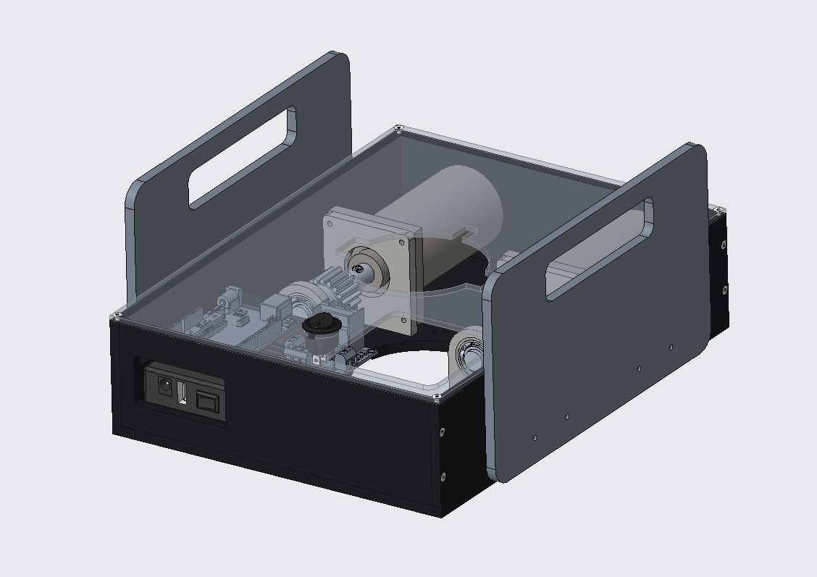

**Figure 29: TerraProbe Travel Mode**

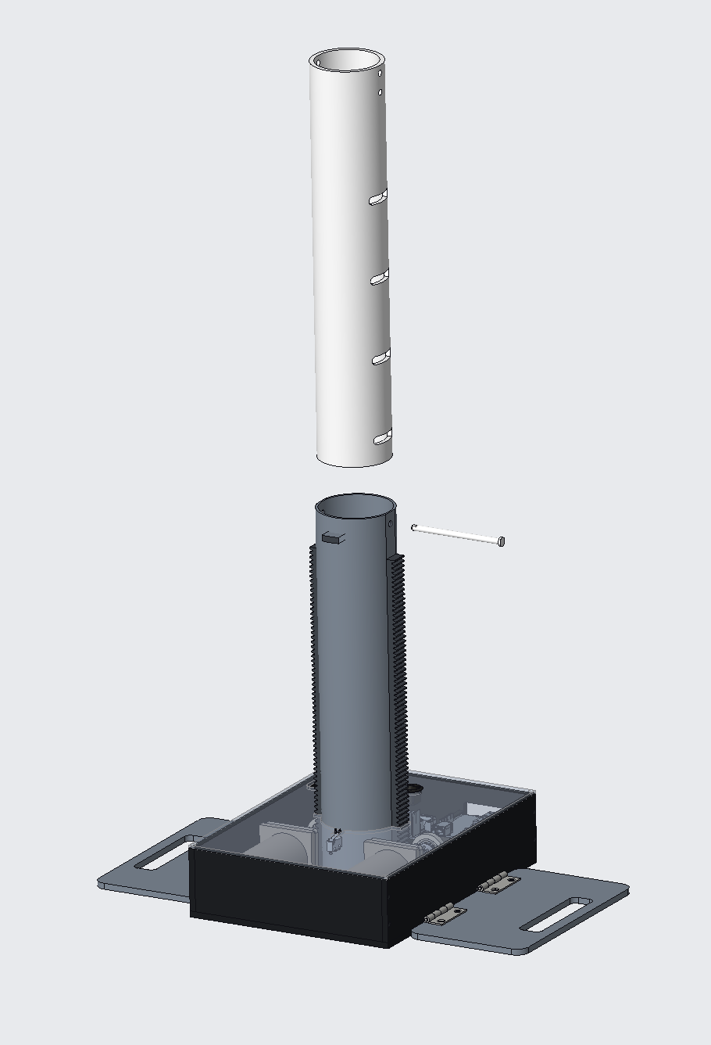

**Figure 30: TerraProbe Semi-Exploded Model**

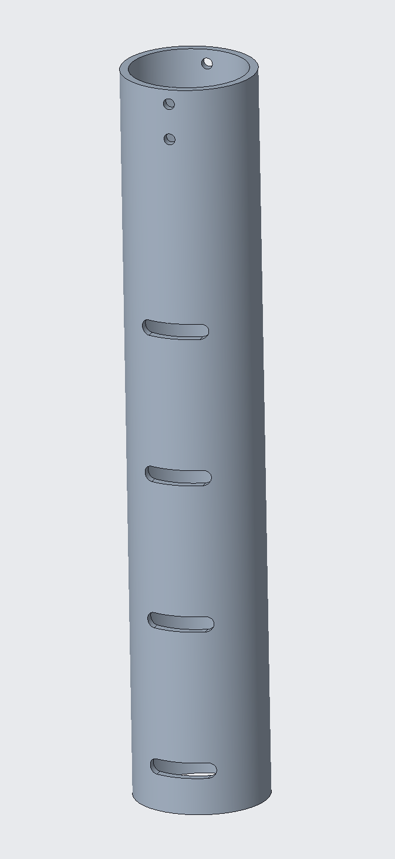

**Figure 31: Payload Chamber**

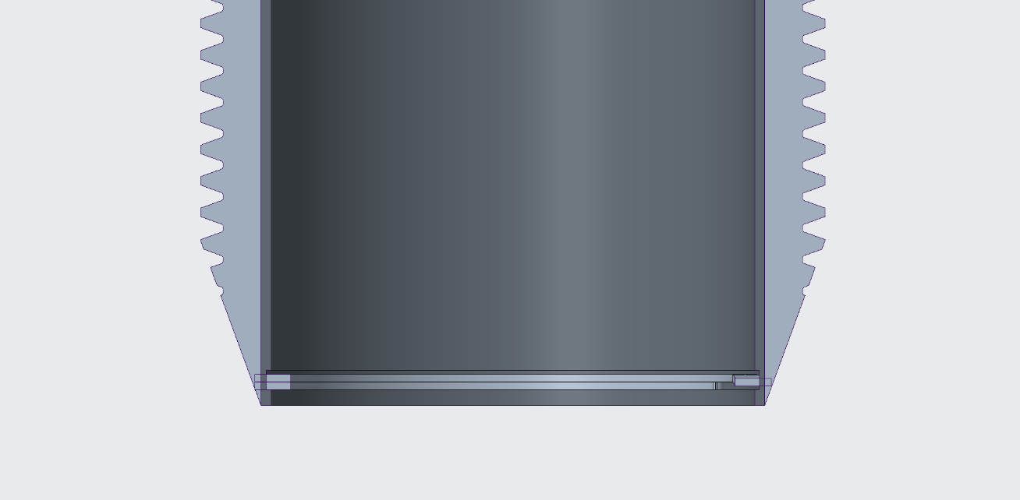

**Figure 32: Shell and Racks Close-Up Cross Section**



**Figure 33: Shell and Racks Sub-Assembly**



**Figure 34: TerraProbe Top View (Lid Off)**

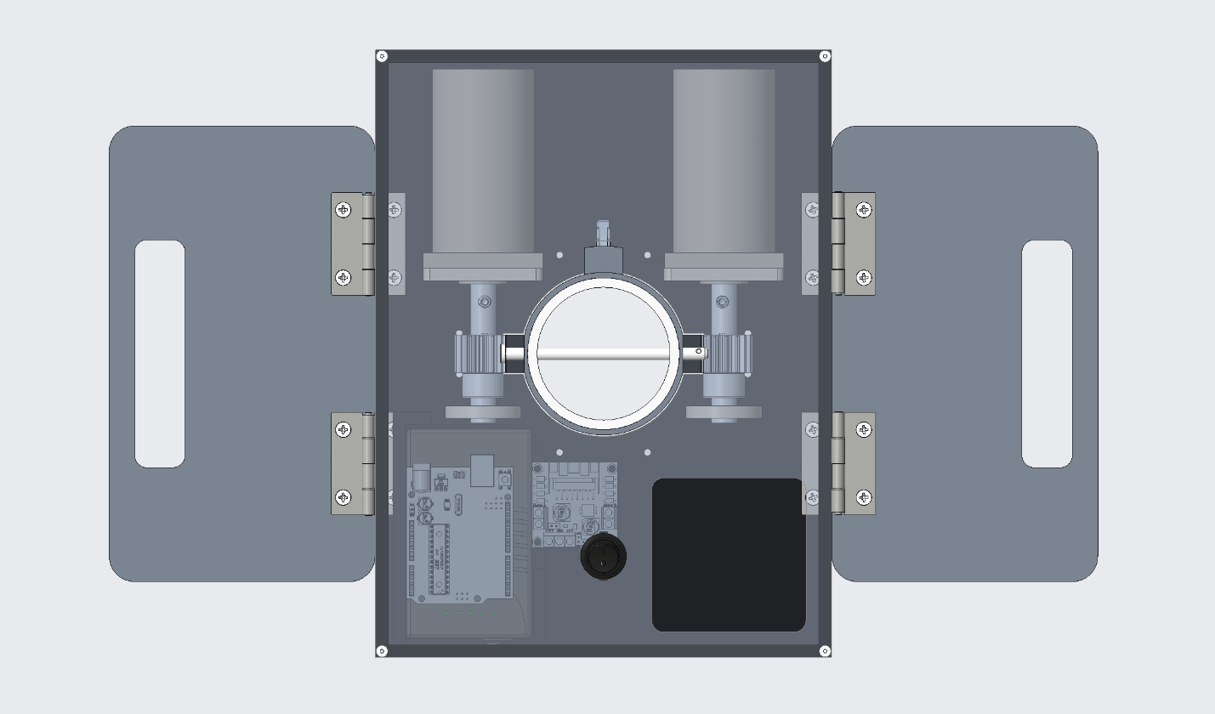

**Figure 35: TerraProbe Top View (Lid On)**

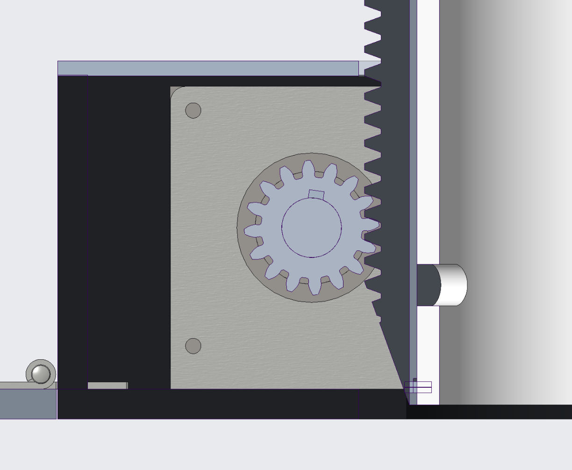

**Figure 36: Shaft, Key, and Pinion Close-Up**

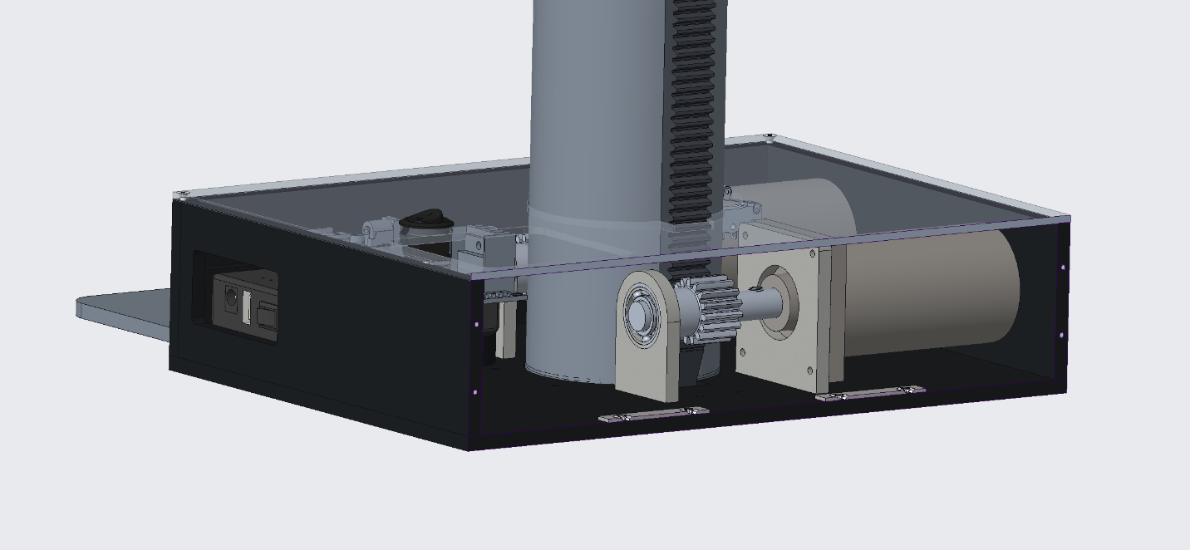

**Figure 37: TerraProbe Side View Cross Section**

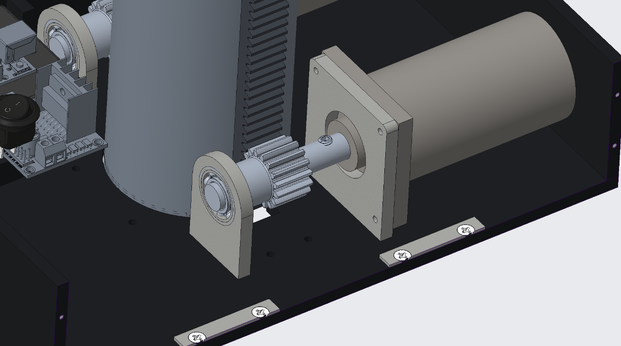

**Figure 38: Gear, Rack, and Pinion Close-Up**

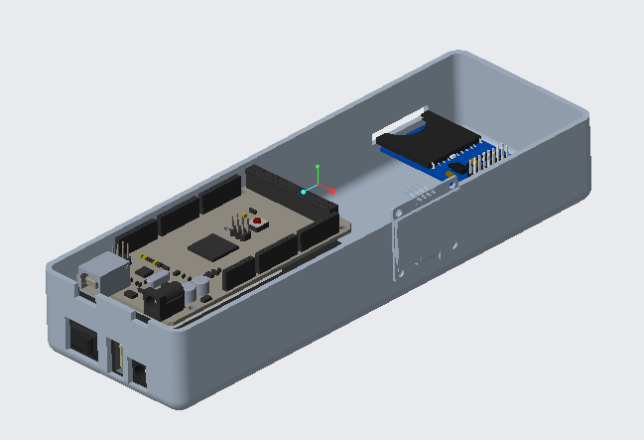



**Figure 39: Soil Testing Probe (NPK & Moisture)**

Motors serve as the main driving mechanism for the rack and pinion system, allowing the Terra Probe to penetrate through the ground. Based on calculations from the analysis section of this report, a low-torque motor with 35W power and 30 RPM was required. Consequently, two 12V DC motors (Hitiland, DC Gear Motor, 12V, China) operating at 30 RPM were selected to operate the system. To control these motors, an L298N Dual H-Bridge motor driver module was used, allowing simultaneous control and power distribution to both motors. The system was programmed using an Arduino Uno microcontroller for computing power and ease of use. A 12V Talentcell rechargeable lithium-ion battery (3000mAh) powered the motors while also supplying 5V to the Arduino Uno. For user functionality and safety, a switch was incorporated to turn the rack and pinion system on and off, including emergency shutdown capability. A red button is also attached to the designed to act as a limit switch, preventing the rack and pinion from digging once the max height of the payload is reached.

The circuit diagram below illustrates the motor control system, detailing all components mentioned above along with their pin connections to the Arduino. Additionally, a barrel plug connects the battery to the motor driver for seamless wiring integration.

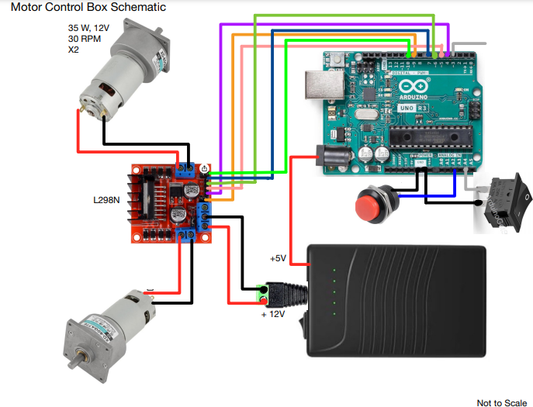

**Figure 40: Electrical Diagram of Motor Controller System**

The TerraProbe system is designed to collect, process, and visualize soil data in real time, integrating both hardware and software components. The data acquisition process begins with embedded sensors connected to an Arduino Mega, which captures and processes real-time soil readings. These readings are stored on an SD card module, ensuring data integrity across multiple depths. The probe's consumable inner payload design features slits at five distinct depths (2”, 4”, 6”, 8”) allowing precise multi-layer soil analysis. Depth selection is controlled through five physical buttons on the probe, enabling structured data collection across all layers. To achieve the project objectives, the following components were used: Arduino Mega, OLED display, NPK soil sensor, soil moisture sensor, transceiver module, SD card module, and 5 analog buttons.

The Arduino Mega was selected due to its superior computing capability and the availability of multiple pin outputs, making it suitable for this multi-sensor data acquisition system. A 12V battery was used to power the NPK soil sensor while also providing a regulated 5V supply for the Arduino Mega. The NPK soil sensor, which measures nutrient levels in the soil (Nitrogen, Potassium, Phosphorus), required an RS485 communication protocol. To facilitate this, a transceiver module was used to convert Arduino’s UART signals into RS485, enabling proper interfacing. Additionally, a capacitive soil moisture sensor was integrated to measure the water content in the soil.

For user interaction, 5 buttons were placed to control the data collection process. This changed from the 5-in-1 analog button that was proposed in CDR due to sourcing and delivery challenges. However, the device functioned the same way as intended. Modifications had to be made to the CAD design to fit in 5 button slots rather than a button module. The system's operational status and data collection updates were displayed on an OLED screen. Once data was acquired, it was stored in a .txt file, which recorded measurements at different depths. The SD card module enabled the transfer and storage of this data onto an SD card, ensuring convenient access for further analysis.

By integrating these components, a data acquisition system was developed as a secondary function of this project. The following diagram illustrates the wiring connections and pin assignments between the Arduino and the various sensors.

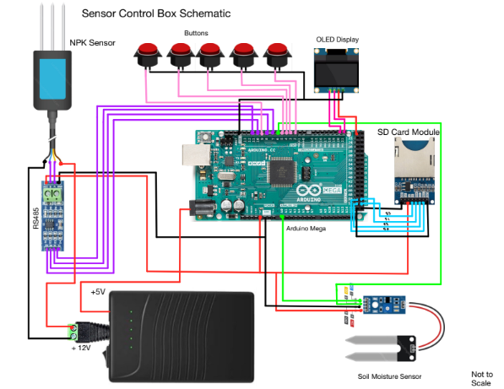

**Figure 41: Electrical Diagram of Soil Testing Probe (Data Acquisition System)**



**Figure 42: Design of Sample Dashboard Set-Up**

1. **Analysis**

**Required Tangential Force from Gears**

This section lays out one model that could be used to analyze the required Torque/Force to push the robot the required height into the soil. To determine all the forces that acted on the robot body, a free body diagram was used



**Figure 43: Free Body Diagram**

* $g=9.81 ms^{-2}$ is the gravitational acceleration
* $a$ is the internal side length of the internal payload
* $b$ is the external side length of the external guidance system
* $A_{o}=a^{2}$ is the external cross-sectional area
* $A_{i}=b^{2}$ is the internal cross-sectional area
* $z$ is the depth into the soil
* $A_{s,o}=4az$ external surface area exposed to soil
* $A_{s,i}=4bz$ internal surface area exposed to soil
* $M$ is the mass of the robot unit
* $W_{robot}=Mg$ is the weight of the robot unit
* $θ$ is the angle of the chamfer at the bottom
* $∆z$ is the height of the chamfer
* $A_{slant}$ is the surface area of the chamfer
* $γ$ is the unit weight of the soil
* $ρ$ is the density of the soil
* $c^{'}$ is the effective cohesion coefficient of the soil
* $Փ$ is the friction angle of the soil
* $m= ρA_{i}z$ is the mass of the collected soil
* $W_{soil}= mg$ is the weight of the collected soil
* $F$ is the required input force (we are solving for this)
* $f_{o}$ is the external friction
* $f_{i}$ is the internal friction
* $F_{soil,static}$ is the “soil-static” pressure on the chamfer

Using the free body diagram, we can find the equation of motion in the $z$ direction and that would be our governing equation

$\sum{F_{z}=2F+f_{i}+W_{robot}+W_{soil}}-f_{o} -F_{soil_{static}}=\left(m+M\right)\ddot{z}$ $\left(1\right)$

We need to ensure that $\ddot{z}$ (the acceleration) is always greater than or equal to zero until the desired height is reached. Once that is solved, the robot can be run at reverse at the same Force/Torque. However, there remain many unknowns: $f_{i}, f_{o}, and F_{soil_{static}}$. According to Purdue University, the following equations can be used to determine the unknown.

$f_{i}=N_{i}\tan\left(Փ\right)$ $\left(2\right)$

$f_{o}=N_{o}\tan\left(Փ\right)$ $\left(3\right)$

Where $N_{i}$ and $N_{o}$ are the normal forces acting on the internal and external walls respectively (the hydrostatic equivalent force on each of the 4 sides of the walls)

$N_{i}=\frac{1}{2}(P_{i}A_{s,i})$ $\left(2.1\right)$

$N_{O}=\frac{1}{2}(P_{o}A_{s,o})$ $\left(3.1\right)$

Where $P_{i}$ and $P_{o}$ are the maximum lateral pressure acting on the internal and external surface respectively. The pressure can be calculated from the Active and Passive earth theory (Purdue et.al). Since the robot is moving through the soil on the external surface, it would experience passive pressure. On the other hand, since the soil is moving through the internal surface, it would experience active pressure. The equations can be seen below

$P_{i}=K_{a}γz-2c^{'}{\left(K_{a}\right)}^{\frac{1}{2}}$ $\left(2.2\right)$

$P_{o}=K_{p}γz+2c^{'}{\left(K_{p}\right)}^{\frac{1}{2}}$ $\left(3.2\right)$

The active and passive pressure coefficients ($K_{a}, K_{p}$) can be calculated using the friction angle

$K_{a}=\frac{1-sin⁡(Փ)}{1+sin⁡(Փ)}$ $\left(2.3\right)$

$K_{p}=\frac{1+sin⁡(Փ)}{1-sin⁡(Փ)}$ $\left(3.3\right)$

There remains one unknown which is the $F_{soil,static}$. This can be treated as a simple pressure distribution case and the equation below can be used to solve the same

$F_{soil,static}=\frac{1}{2}\left(K_{p}γ\left(2z+∆z\right)+4c^{'{\left(K_{p}\right)}^{\frac{1}{2}}}\right)A_{slant}$ $\left(3\right)$

Using these equations, we can determine the minimum required force by pre-determining the desired motion profile. However, it is important to make note of the assumptions we made to derive the equation

* The soil is a homogenous substance (soft cohesive soil)
* Soil has negligible water content
* Soil has constant properties
* Gear rack surface area << than surface area of payload
* Internal friction is considered negligible due to the creation of a “lip” at the bottom of the internal payload
* Assume cohesion ~ 20 KPa (typical property of loamy soil)
* Friction on cone tip is << friction on the entire surface
* $A_{slant}$ << $A_{s,o} or A_{s,i}$

So, from the above model we estimate that the force required from each motor will be around **~925 N (207.9 lbf)** ; This value can vary significantly as the cohesion value greatly changes our results.

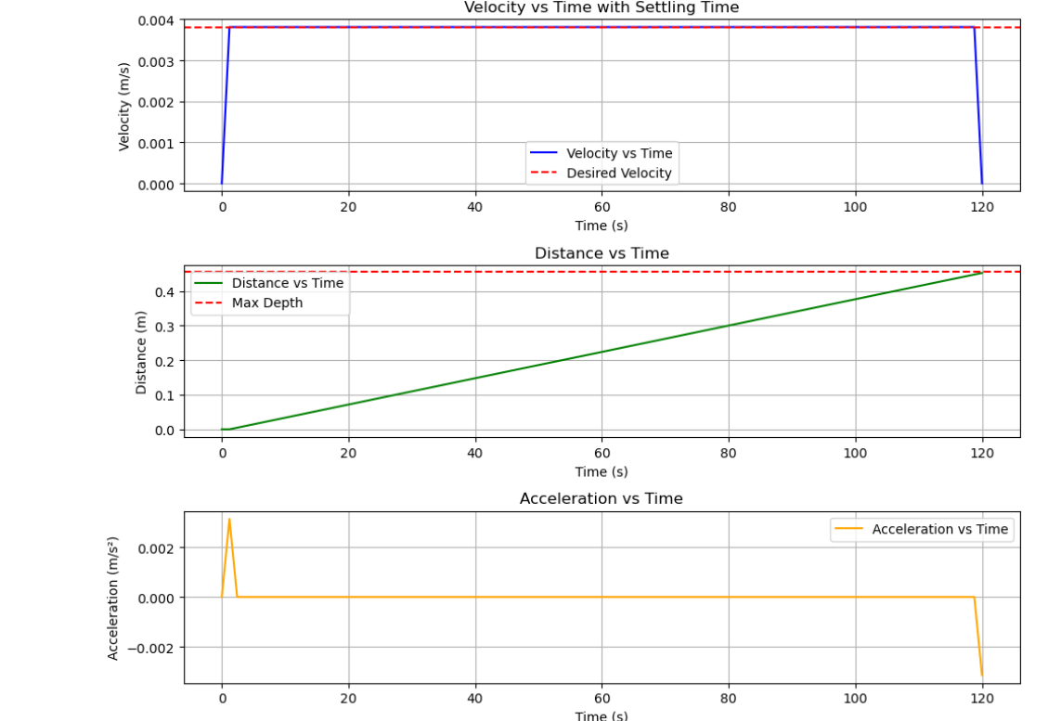

**Figure 44: Desired Motion Profile with constant velocity**

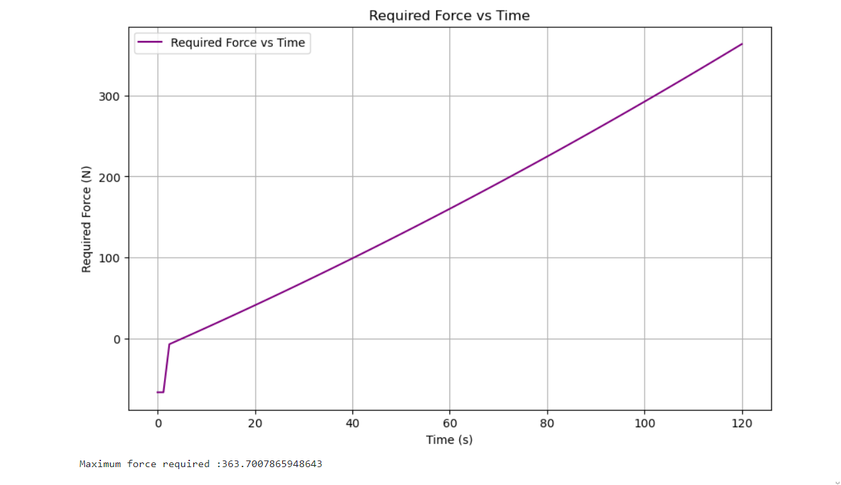

**Figure 45: Resulting Required Force over time to reach the desired depth**

**Failure analysis for Rack and Pinion mesh**

To design the rack and pinion system, the minimum number of teeth on the pinion needed to be determined to avoid undercutting. This can be seen in the equation below

$$\left(eq 13-10\right) N_{p }=\frac{2\left(k\right)}{\sin^{2}{Փ}}$$

Where $N_{p }$ is the minimum number of teeth on the pinion, $k (contact ratio)=0.9$, and $Փ$ is the pressure angle. Plugging in $Փ={20}^{o}$ and rounding up to the nearest whole number, we get that $N_{p }=16$. Since the team needs a large tangential force and the gear needed to be small, we chose a gear with a diameter of 1 inch. This results in an equivalent transversal pitch (of both the rack and the pinion), $P_{d}=\frac{N_{p}}{d_{p}}=16$. Using the equation below, we can then determine the pitch line velocity of the 2-gear mesh

$$\left(eq 13-34\right) V= \frac{πdω}{12}$$

Where $V$ is the pitch line velocity in ft/min, $d$ is either pinion/gear diameter in inches, and $ω$ is either the angular velocity in rpm of the pinion/gear. Substituting the relevant values, we get $V= 7.20 ft/min$. Furthermore, we can use the equation below to determine the tangential load acting between the mesh

$$\left(eq 13-35\right) W^{t}= \frac{33000H}{V}$$

Where $W^{t}$ is the tangential load in lbf, and $H$ is the power generated in Horsepower. This equation is crucial in motor selection as $W^{t}$ would need to be a minimum of 207 lbf. A motor that ran at 35 W, had a rated rpm of around 30 rpm was chosen. Substituting the relevant values, we get $W^{t}= 213. 90 lbf$. Finally, using Table 13-3 from shigley’s, the face width needed to be a minimum of $F=\frac{10}{16}=0.62 in$ for both the rack and the pinion. Now that the key variables have been determined, we can move on to stress and factor of safety analysis. AGMA recommends using a quality factor $Q_{v}=7$ and Reliability $R=99\%.$ The desired life was decided as $N={10}^{6}$.Since we know the pinion is likely to fail first, due to having going through more loading cycles than the rack, if we design for the pinion to not fail, the rack will not fail either. The gear contact stress can be written as shown in equation 26 and the gear bending stress can be seen in the equations below

$$\left(eq 14-16\right) σ_{c}=C_{p}{\left(W^{t}K_{o}K_{s}K_{v}*\frac{K_{m}}{F*d_{p}}*\frac{C_{f}}{I}\right)}^{\frac{1}{2}}$$

$$\left(eq 14-15\right) σ=W^{t}K_{o}K_{s}K_{v}*\frac{P_{d}}{F}*\frac{K_{m}K_{b}}{J}$$

Each key variable and constant are listed in Table XX below along with how the constants were found.

**Table 5: Key Variables and Constants for Contact Stress and Bending Stress analysis *Check python attached in appendix for the calculations**

|  |  |  |  |
| --- | --- | --- | --- |
| Variable/Constant | Physical Meaning | Numeric Value | Shigley Source |
| $$σ_{c}$$ | Gear Contact Stress | $$62.67 kpsi$$ | eq 14-16 |
| $$σ$$ | Gear Bending Stress | $$26.56 kpsi$$ | eq 14-15 |
| $$C_{p}$$ | Elastic Coefficient | $$2300 psi^{\frac{1}{2}}$$ | Table 14-8 |
| $$W^{t}$$ | Tangential Load | $$213.90$$ | eq 13-35 |
| $$K_{o}$$ | Overload Factor | $$1.00$$ | ANSI/AGMA standard |
| $$K_{s}$$ | Size Factor | $$1.00$$ | ANSI/AGMA standard |
| $$K_{v}$$ | Dynamic Factor | $$1.03$$ | eq 14-27 |
| $$K_{m}$$ | Load Distribution Factor | $$1.19$$ | eq 14-30 |
| $$K_{b}$$ | Rim Thickness Factor | $$1.29$$ | eq 14-40 |
| $$F$$ | Face Width | $$0.75 in$$ | table 13-3 |
| $$d_{p}$$ | Pinion Diameter | $$1.00 in$$ | Problem Statement (Term Project) |
| $$P_{d}$$ | Transversal Pitch | $$5.00 teeth/in$$ | ANSI/AGMA Standard |
| $$C_{f}$$ | Surface Condition Factor | $$1.00$$ | ANSI/AGMA Standard |
| $$I$$ | Geometry Factor | $$0.47$$ | eq 14-23 |
| $$J$$ | Geometry Factor | $$0.27$$ | fig 14-6 |

Now that the stresses have been determined, the fatigue factor of safety can be computed using the equations seen below

$$\left(eq 14-42\right) S_{H}=\frac{S_{c}Z_{N}C_{H}}{K_{T}K_{R}σ_{c}}$$

$$\left(eq 14-41\right) S_{T}=\frac{S_{t}Y_{N}}{K_{T}K_{Rσ}}$$

To begin with, the material chosen was AISI Steel 1144, Hardened as it has the lowest strength hence presents the cheapest option. A table with all the key variables/constants is present below

**Table 6: Key Variables and Constants for Factor of safety analysis**

|  |  |  |  |
| --- | --- | --- | --- |
| Variable/Constant | Physical Meaning | Numeric Value | Shigley Source |
| $$S_{H}$$ | Wear Factor of Safety | $$1.81$$ | eq 14-42 |
| $$S_{T}$$ | Bending Factor of safety | $$3.49$$ | eq 14-41 |
| $$Z_{N}$$ | Stress Cycle Factor | $$1.05$$ | fig 14-15 |
| $$Y_{N}$$ | Stress Cycle Factor | $$1.04$$ | fig 14-14 |
| $$C_{H}$$ | Hardness ratio Factor | $$1$$ | section 14-12 (gear only assumption) |
| $$K_{T}$$ | Temperature Factor | $$1$$ | ANSI/AGMA Standard (T<250 F) |
| $$K_{R}$$ | Reliability Factor | $$1.00$$ | eq 14-38 |
| $$S_{t}$$ | Bending Strength | $$89 kpsi$$ | MatWeb |
| $$S_{c}$$ | Contact Strength | $$108 kpsi$$ | MatWeb |

The desired factor of safety was minimum of 1.5. From Table 12, we see that both the wear and bending factors of safety are greater than 1.5, Hence, AISI 1144 Steel gears would satisfy the design requirements

The rack and pinion system in TerraProbe is the mechanism by which we convert rotational motion into vertical translation. It is central to consider multiple design details such as, but not limited to, gear pitch, face width, material selection, and tangential load. Aside from design considerations, the rack and pinion interface need to be designed for precise assembly – to ensure that the gear tooth are always in contact.

As the gear will go through a larger number of cycles than the rack, yield and fatigue analysis need to be done on the pinion. AGMA standards were used to conduct the same. The pinion gear would experience two forces: the Tangential and the perpendicular force. This can be seen in the free body diagram below

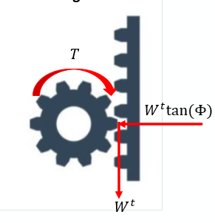

**Figure 46: Pinon Rack Interface Forces**

Since the device needs to be portable, the pinion chosen had a pitch diameter of 1 inch, a pitch of 16 teeth/inch, and face width of 0.75 inch. Hence it follows that the rack would have the same pitch and face width as the pinion. Using these properties the gear contact ($σ_{c}$) and bending stresses ($σ_{b}$) on the gear teeth were calculated (Refer to Appendix A.3 for the same)

$$σ_{c}= 62627.64 psi \left(or\right) 62.6 kpsi$$

$$σ_{b}=26561.67 psi \left(or\right) 26.7 kpsi$$

Now that there is an estimate of the stresses the gear teeth will experience, the team needed to choose pinions and racks that meet the mechanical and financial requirements while being easy to procure. The gear chosen was made from 1144 hardened steel and the rack chosen was made from 1215 steel (part numbers 5172T63 and 5174T12 from McMaster Carr respectively). Now that the parts were chosen, the bending ${(S}_{T})$ and wear ${(S}_{H})$ factor of safety were calculated

$$S_{T}=3.49$$

$$S_{H}=1.81$$

Since both factors of safety are well above 1.5, the part selection was justified. The full calculation to determine the parameters that influence the factor of safety, such as geometry factors, load factors, and surface factors, can be seen above.

**Shaft Design**

The shafts will be designed first as the keys and bearings will be dependent on the design of the shaft. The input shaft is connected to a motor unit through a 1-inch diameter connection. Our first step will be to find the bending moment and shear force load across the shaft. To do this, we will start with finding the reaction forces and creating bending moments and shear diagrams.

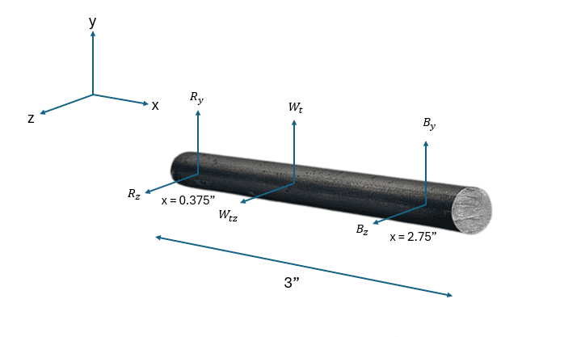

**Figure 47: Shaft Design Free-Body Diagram**

The Figure above shows the forces acting on the shaft. There are 3 main forces: motor assembly reaction forces, tangential load provided by the gear, and the bearing reaction forces. Reaction Forces at Bearings ($B_{1_{y}}, B_{1_{z}}$). We can sum the moments and force to yield the reaction forces at bearings, considering the specified loads and connections. From the torque and gear calculations, we know that 958.3 N is the gear tangential force in the y-direction. With a gear angle of 20 degrees, we can find the gear force in the z-direction as well. The reaction forces below show the calculated values:

Therefore, our reaction forces for vectors $R_{1} and B_{1}$ become the following:

$$R_{1}=\left(124.3j+45.2k\right) lbf$$

$$B_{1}=\left(89.6j+32.6k\right)lbf$$

We can also calculate the torque that is applied to the system using radius of the pinion (0.5 in) and the force that is applied on the gear (Wt):

$$T=\left(0.5 in\right)\left(-239.6 lbf k\right)→T=-106.95 lbf in$$

The Shear, Bending Moment, and Torque Diagrams for x-y planes are illustrated, aiding in understanding loading conditions.

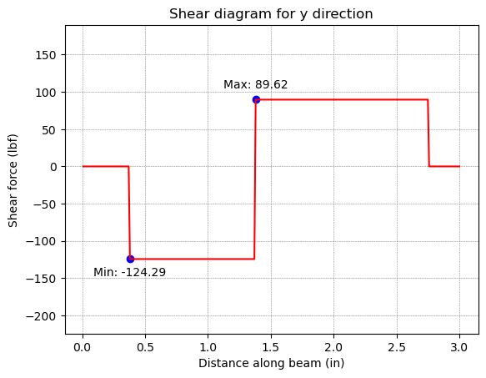

**Figure 48: Shear Diagram y-direction**

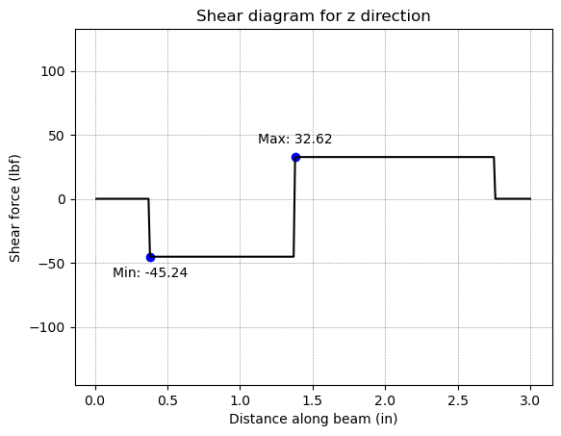

**Figure 49: Shear Diagram z-direction**

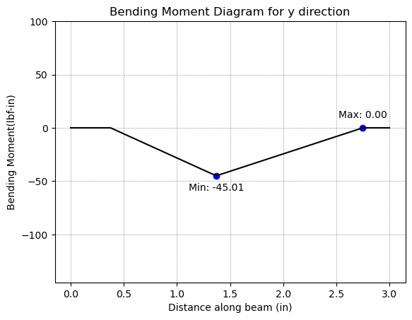

**Figure 50: Bending Moment Diagram y-direction**

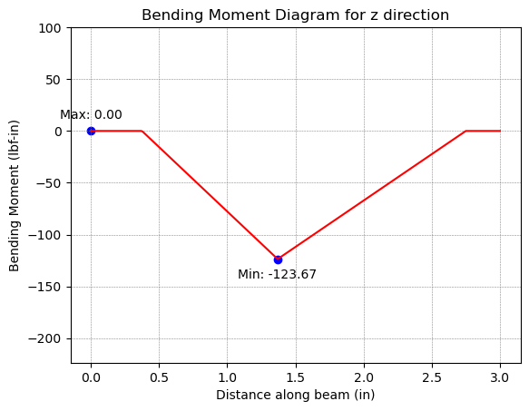

**Figure 51: Bending Moment Diagram z-direction**

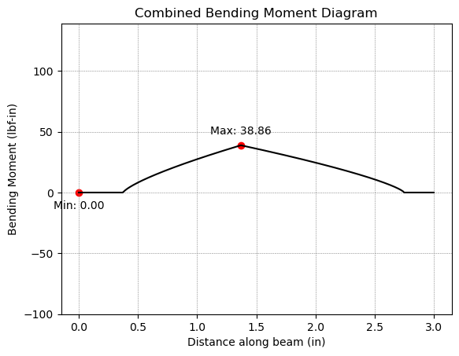

**Figure 52: Combined Bending Moment Diagram**

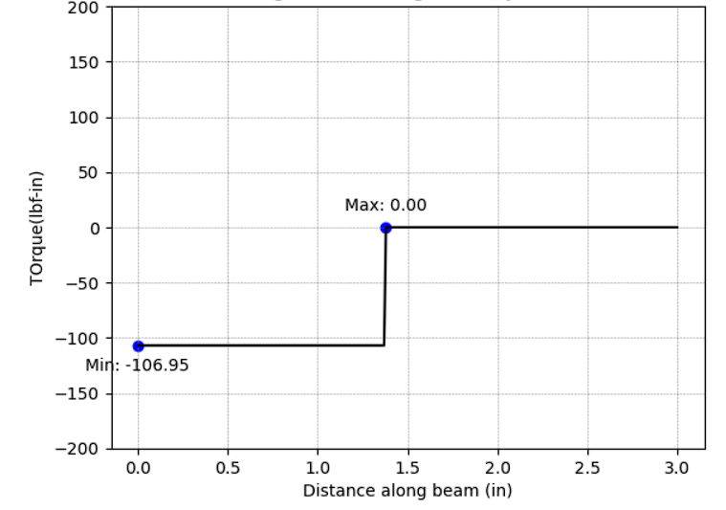

**Figure 53: Torque Diagram for Shaft**

From the maximum moment values generated, we can examine how our shaft will perform at high stress areas particularly the gear-key mechanism. We can calculate the alternating and mid-range values for torque and moment at key points of interest. The equations below show the formula for calculating the alternating and mid-range values:

$M_{a}=\frac{(M_{max}-M_{min})}{2}$ $M_{m}=\frac{(M_{max}+M_{min})}{2}$

$T_{a}=\frac{(T_{max}-T_{min})}{2}$ $T_{m}=\frac{(T_{max}+T_{min})}{2}$

Based on these critical points and obtained alternating/mid-range moment and torque values, we can calculate the Von-Mises stress at each of the points of interests. The Von-Mises stress can be calculated based on the following equation shown below. Since we know that $M_{m}$ and $T_{a}$ are 0 lbf in at all points of interest, we can further simplify these equations:

$$σ_{a}^{'}={{[(\frac{32K_{f}M_{a}}{πd^{3}})}^{2}+3{(\frac{16K_{fs}T_{a}}{πd^{3}})}^{2}]}^{\frac{1}{2}}→σ_{a}^{'}={(\frac{32K_{f}M_{a}}{πd^{3}})}^{2}$$

$$σ_{m}^{'}={{[(\frac{32K_{f}M_{m}}{πd^{3}})}^{2}+3{(\frac{16K_{fs}T_{m}}{πd^{3}})}^{2}]}^{\frac{1}{2}}→{σ_{m}^{'}=[3{(\frac{16K_{fs}T_{m}}{πd^{3}})}^{2}]}^{\frac{1}{2}}$$

In order to adequately solve the Von-Mises stresses, we need to also find information such as the diameters at the points of interest and the stress concentration factors at critical points such as keys based on moment and torque loadings. The diameter of the shaft will be 0.5 inches throughout the length of the shaft.

At the point of interest x = 1.37 inch along the shaft, we have a key to connect the gear to the shaft. Using Table 7-1 from Shigley, we find the end-mill key seat (r/d = 0.02) stress concentration factors as the following. We will also assume that $K_{t}=K_{f}$, which yields a notch sensitivity of 1:

$K_{t}= 2.14$ $q=1$

$K_{ts}= 3$ $q_{s}=1$

$$K_{f}=1+1\left(2.14-1\right)=2.14$$

$$K_{fs}=1+1\left(3-1\right)→K_{fs}=3$$

The calculations were performed in Python using the above equations. The table below represents the values that we obtained based on the input specified above.

**Table 1: Stress Values at Points of Interest**

|  |  |  |  |  |  |  |
| --- | --- | --- | --- | --- | --- | --- |
| X [in] | $$σ_{a} [psi]$$ | $$σ_{m} [psi]$$ | $$τ_{a} [psi]$$ | $$τ_{m} [psi]$$ | $$σ_{m}^{'} [psi]$$ | $$σ_{a}^{'} [psi]$$ |
| 1.37 | 3166.26 | 0 | 0 | 4357.66 | 22643.08 | 6775.81 |

Now finally using these von-misses stresses, we can calculate the fatigue factor of safety to check if infinite life is predicted and calculate the yield factor of safety to check for first cycle yielding. It is important to remember that we assumed that the material is AISI 4140 steel with Sut = 225 kpsi and Sy = 208 kpsi. The equations below show how the calculation for fatigue and yield factor of safety:

$$n_{f}={(\frac{σ_{a}^{'}}{S_{e}}+\frac{σ_{m}^{'}}{S_{ut}})}^{-1}$$

$$n_{y}=\frac{S_{y}}{σ_{a}^{'}+σ_{m}^{'}}$$

Looking at the above equations, all of the parameters are known for each point of interest except $S_{e}$, which is the endurance limit, the limit that tells us that if the part is operator under certain stress, it is predicted for infinite life.

The endurance limit can be calculated as shown:

$$Se=k_{a}k_{b}k_{c}k_{d}k_{e}Se'$$

$$Se^{'}=0.5*S_{ut}→Se^{'}=0.5\left(225\right)=112.5 kpsi (Eq 6-10)$$

$$k_{a}=2{(S_{ut})}^{-0.217}→k_{a}=2{(225)}^{-0.217}=0.617 (Cold-Drawn)(Eq 6-18)$$

$$k_{b}=0.879d^{-0.107} (Dependent on diameter)(Eq 6-19)$$

$$k_{c}=1 (combined loading)(Eq 6-25)$$

$$k_{d}=1 (assume room temperature)$$

$$k_{e}=1 (assume 50\% reliability)(Table 6-4)$$

Using these calculations to calculate endurance limit, along with the von-misses stresses and the ultimate strength of the chosen material, the following factors of safety values are obtained for each point of interest:

|  |  |  |
| --- | --- | --- |
| X [in] | $n_{f}$– Fatigue Factor of Safety | $n_{y}$– Yield Factor of Safety |
| 1.37 | 4.43 | 8.8 |

By approximating and choosing a diameter, we tested all the critical points (points of interest) for fatigue and yield failure. We can choose a design factor of 1.5 to ensure that the part won’t fail and since the fatigue and yield factor of safety values was greater than 1.5, we can successfully design the shaft with the following values.

**Key Design**

To design the key, we need to consider both the failure due to shear and failure due to crushing. The formulas to determine the corresponding factors of safety and stress can be seen below

$${\left(17\right) n}_{τ}=\frac{S_{sy}}{τ}=\frac{0.577S_{y}}{τ},τ=\frac{T}{rwl}$$

$$\left(18\right) n_{c}=\frac{S_{y}}{σ_{c}},σ_{c}=\frac{2T}{hrl}$$

Where $n_{τ}$ is the shear factor of safety, $n_{c}$ is the crushing factor of safety, $S_{y}$ is the yield strength, $τ$ is the shear stress, $σ_{c}$ is the crushing stress, $r$ is the radius of the shaft, $w$ is the key width, $l$ is the key length, and $h$ is the key height. From part the shaft design section we know that the r = 0.5 in (1.0/2). To simplify the design, a square key will be used. According to table 7-6 from Shigley’s, a 3 in shaft could have square key dimensions $w=h=\frac{1}{8} in$. From the force analysis in the previous section, we know the torque at the point is $T=106 lbf.$ The only unknown left to solve for is the $l$. A desired factor of safety of 1.5 was set. The equations above can be rearranged and solved as follows

$$l≥\frac{{Tn}_{τ}}{0.577S_{y}rw} ↔l≥ 0.197 in$$

$$l≥\frac{{2Tn}_{c}}{S_{y}rh} ↔l≥ 0.228 in$$

To satisfy both inequalities let $l≥0.228 in$. Hence the final dimensions and the strength of the key on the input shaft are: (corresponding to McMaster Part # 98870A090)

$$w=0.125 in, h=0.125 in, l=0.25 in$$

**Bearing Design**

To enhance the safety of the shaft by keeping the gear in place, the design will house a bearing on the shaft. Using the bearing reaction forces and the design equation below, we can design a ball bearing for a given reliability, design life, and catalog life to find the catalog load.

$$a_{1}\left(C_{10}\right){\left(L_{10}\right)}^{\frac{1}{a}}=(F_{D}){(L_{D})}^{\frac{1}{a}}$$

Given a reliability of 90%, $a_{1}=1$, the design life $L_{D}=15000 hrs$, assume catalog life of ${10}^{6}$, and $a=3$ for ball bearings, we can calculate the design load based on the bearing reaction forces we calculated for the input shaft.

$$R_{B1}=\sqrt{{{(R}_{B1,y})}^{2}+{{(R}_{B1,z})}^{2}}→R_{B1}=95.37 lbf$$

Based on the following parameters, the catalog load ($C_{10}$) value can be calculated.

The bore diameter of the bearing needs to match the shaft diameter of the region which is 0.5 inch for this bearing. Using a McMasterCarr catalog, we can find a bore diameter of 0.5 inch that meets or exceeds the catalog load requirement obtained: *https://www.mcmaster.com/60355K291/ (Static Load Max: 530 lbf, Dynamic Load Max: 1140 lbf Max RPM: 25k)*.

The shaft design is critical to the functionality and reliability of the TerraProbe, as it connects and mounts the motor to the gear system while ensuring smooth and efficient power transmission. A ball bearing is mounted at the end of the shaft to enhance stability and safety, preventing misalignment or excessive wear over time. The shaft, with a length of 3 inches and a diameter of 0.5 inches, experiences three primary forces: assembly reaction forces from the motor mount acting at 0.375 inches, tangential loading due to the gear, and shear forces from rotational motion. The tangential loading force, determined through the motor selection and torque analysis, was calculated to be 213.84 lbf.

To ensure durability and mechanical integrity, the shaft is made from AISI 4140 steel, providing high strength and fatigue resistance. The analysis yielded a fatigue factor of safety of 4.4 and a yielding factor of safety of 8.8, both significantly exceeding the required design factor of 1.5. This additional safety margin accounts for unforeseen stresses that may arise during operation. The bearing loads, calculated at 89.62 lbf in the y-direction and 32.62 lbf in the z-direction, guided the selection of appropriate bearings. Based on these loads, McMaster-Carr bearings (60355K291) were chosen, offering a static load capacity of 530 lbf, a dynamic load capacity of 1140 lbf, and a maximum operating speed of 25,000 RPM. These design considerations ensure the shaft assembly operates with high efficiency, minimal wear, and long-term reliability under varying soil conditions. Detailed shear force, bending moment, and combined bending analyses are included above.

The key design for the TerraProbe's shaft is important to ensure proper power transmission and preventing relative rotation between the shaft and its connected components. A square key with dimensions of 0.125 inches for both width and height were selected based on the shaft diameter of 0.5 inches, following AGMA recommendations. The key length was determined to be 0.25 inches, satisfying both shear and crushing safety requirements with a factor of safety of 1.5. (Refer above for the AGMA equations utilized)

The key material chosen was AISI 1045 Carbon steel, providing adequate strength to withstand the calculated torque of 106 lbf. This design ensures that the key can effectively transmit power from the motor to the gear system without failure due to shear or crushing stresses. The selected key dimensions (w = 0.125 in, h = 0.125 in, l = 0.25 in) correspond to McMaster-Carr Part # 98870A090, which offers standardized, readily available components for ease of manufacturing and maintenance.

1. **FMEA**
   1. The Failure Mode Effects Analysis file is attached called “FMEA_FDR.xlsx”

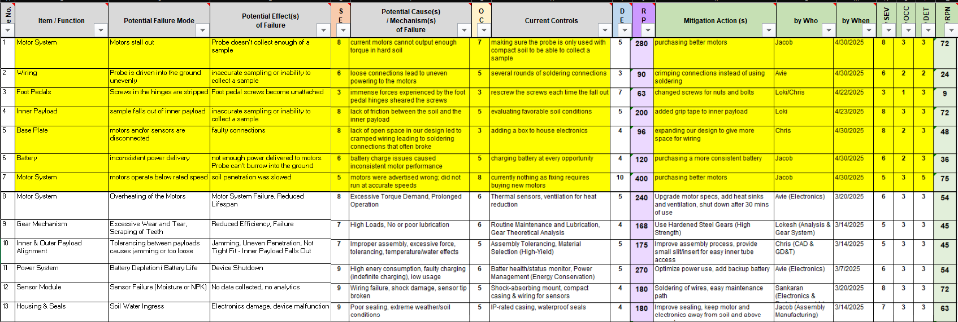

The Failure Modes and Effects Analysis (FMEA) identified key risks across various subsystems/subassemblies of the project, with a focus on the mechanical, electrical, and software components. The highest initial RPN values were observed in Power System Failure (270) and Motor Overheating (240) due to their severe impact on device functionality. Mitigation strategies, such as optimizing power consumption, incorporating backup batteries, and improving ventilation, were brainstormed and incorporated into the CDR design to reduce risk. Other critical issues, including Sensor Failure, Soil Water Ingress, and Loose Mechanical Couplings, were addressed through enhanced sealing, shock-resistant mounting, and reinforced fasteners. Following mitigation, the recalculated RPN values indicate a significant reduction in risk, improving system reliability and ensuring the device performs efficiently in real-world conditions.

After our CDR presentation, we identified several critical failure modes across different components of the system, primarily focusing on the motor system, wiring, foot pedals, inner payload, base plate, and battery. The highest risk issues involved motor stalling and reduced motor speed, both due to insufficient motor capabilities, resulting in significant impacts on soil penetration and sample collection. Other notable failures included wiring disconnections, stripped screws on foot pedals, and inconsistent battery performance. Mitigation actions such as purchasing better motors, crimping connections, changing screws for nuts and bolts, and improving the inner payload grip were proposed, with responsibilities and deadlines assigned to team members. The highest Risk Priority Numbers were associated with motor issues, highlighting the urgent need for component upgrades to ensure reliable performance.

1. **BOM & Sourcing Plan**

Budget_BOM.xlsx is attached to this document

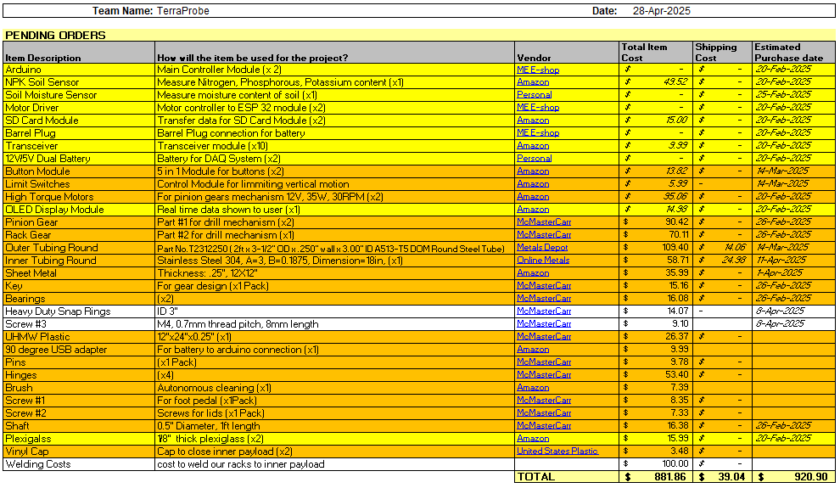

Apart from the above outlined materials, only the key for the gear will be made by the TerraProbe team. All other parts will be bought from the respective vendors listed. After our CDR presentation, several changes were made to our BOM and sourcing plan. First, we had to order new motors as the original vendor was blocked by Purdue University. We also switched our design from using a 5-in-1 button pad to five individual buttons sources from the Purdue E shop. Again, this was due to Amazon vendor issues. As screws were added to our design, those needed to be purchased as well. The last major purchase was the snap ring to fit inside our outer payload to hold our inner payload. Besides these major purchases, minor purchases included various electronics and manufacturing costs such as welding.

**Table 7. Make or Buy Table with Justifications**

|  |  |  |
| --- | --- | --- |
| **Component** | **Make/Buy** | **Justification** |
| Inner Payload | Make | Requires specific shapes that are best controlled in-house. |
| Outer Payload | Make | Custom design requirements make in-house production preferable. |
| Sensor Probe Casing | Make | Custom casing ensures proper fit for sensors and electronics. |
| Foot Pedals | Make | Custom design is required to meet project needs. |
| Sensors | Buy | Precision components that are not feasible to manufacture. |
| Electronics | Buy | Specialized components require external sourcing. |
| Batteries | Buy | Standardized and regulated components best sourced externally. |
| Gears | Buy | Complex manufacturing process and high production cost. |
| Shafts | Buy | Bought at standard size and manufactured as needed by ME shop. |
| Motors | Buy | Precision-engineered components require external expertise. |
| Snap Ring | Make | Custom modifications need to be made |
| Base Plate | Make | Custom cutouts and screw holes are necessary |
| Vinyl Caps | Buy | Cheap part that wouldn’t be feasible to make |
| Screws | Buy | Not feasible to manufacture |
| Hinges | Buy | Cheap part that wouldn’t be feasible to make |

1. **Validation Plan & Test Feasibility**

The testing and validation plan ensures that all components and subsystems function as expected, meet design tolerances, and integrate seamlessly. The plan focuses on validating individual components, testing mechanical and electrical aspects. By systematically testing smaller functional units before full integration, the project aims to achieve reliable operation

**Component Testing (Mechanical, Electrical, and Preliminary Validation)**

Component testing verifies the functionality and durability of individual parts before integration. This includes testing motors, sensors, mechanical components, and structural elements to ensure they meet performance standards under various conditions.

* Motors (Controller Design, Encoder Counts, Controls Testing)
  + Run motors at different speeds and monitor encoder feedback for performance accuracy.
  + Determine digital PWM to operate motor at desired conditions
  + Conduct system Identification and measure and set motors’ two percent settling time to approximately 1-2s
  + Design PI controller using motor as plant to measure and ensure steady state error
* Sensors – NPK, Moisture
  + Calibrate sensors using controlled soil samples with known nutrient and moisture levels.
  + Perform tests to validate measurements in extremely dry/moist soil
* OLED Display Panels
  + Display patterns/text to test brightness, contrast, and response time.
  + Run the display for long periods of time and check for any errors
  + Verify readability under different lighting conditions.
* Rack and Pinion
* Key/Gear/Shaft
  + Measure dimensions using calipers and micrometers for precision.
  + Conduct rotational testing to ensure smooth operation and identify any misalignment.
  + Apply torque testing to assess load-bearing capacity.
* Shaft/Motor System
* Test under various loads to monitor stability and performance.
  + Analyze wear and tear over prolonged operation.
  + Ensure fits are appropriate.
  + Conduct vibration testing to ensure mechanical stability.
* Structural Integrity (Casing, Pins, and Tolerances)
  + Verify the inner/outer casing fit using precision measurement tools.
  + Conduct environmental stress tests, submerging and removing the payload from soil

**System & Assembly Testing**

System testing evaluates how components function together. This phase ensures the complete system operates efficiently by validating motion mechanics, soil collection, and structural integrity.

* Motor-Pinion-Rack System
  + Run the full system under load to assess forward and backward movement
  + Analyze backlash, gear meshing, and alignment.
* Soil Collection Validation
  + Perform field tests in various soil types to ensure effective collection.
  + Compare collected samples against expected volume and consistency.
  + Validate automation for repeatability and efficiency.
* Weight Testing
  + Measure system weight in different operational states (with and without soil) and ensure the total weight is below the maximum limit
  + Ensure consistency through repeated trials with multiple soil types.
* Probe, Data, and Analytics
  + Compare collected probe data with reference values for accuracy.
  + Test data transmission and logging for reliability.
  + Analyze recorded data for inconsistencies and sensor drift – correct (if necessary) with Kalman Filters
* Sub-Assembly & Final Integration Testing
  + Conduct functional tests for sub-assemblies like the testing probe and shaft-pinion-rack before full integration.
  + Verify proper fit, alignment, and operational efficiency.
  + Perform final testing post-assembly to validate overall performance.
  + Conduct environmental stress tests, including temperature and humidity variations.
  + Perform insertion/removal force tests on pins to check ease of assembly and secure fitting.

**Validation Test – Soil Compactness vs. Depth Performance (Procedure & Results)**

**Design Objective:** Verify TerraProbe's ability to meet the 12-inch burrowing requirement under varying soil compaction conditions.

Soil types encountered in the field vary from dry, loose soil to moist, moderately dense, and highly compacted soil. Understanding the effect of soil moisture and compactness on TerraProbe's burrowing capability is critical for validating system performance.

**Test Setup:**

* **Base material:** ~5,000 cubic inches of dry garden soil
* **Moisture Adjustment:** 128 oz (~1 gallon) of water added per cycle (~5% volume per addition)
* **Measurement:** Depth burrowed (inches) recorded after each water addition

**Testing Observations:**

* **Dry Soil (0 oz water):** High resistance due to lack of particle cohesion; limited burrowing observed.
* **Increasing Moisture (128–256 oz):** Soil cohesion improved; noticeable improvement in burrowing depth.
* **High Moisture (384–512 oz):** Soil became sticky and more cohesive, aiding deeper burrowing and easier soil penetration.

The table below shows the results for the depth burrowed in inches:

**Table XX. Water Added vs. Soil Depth Burrowed**

|  |  |  |  |
| --- | --- | --- | --- |
| Water Added (oz) | Approximate Moisture by Volume | Approximate Condition | Depth Burrowed (inches) |
| 0 | 0% | Powdered | 1.21 |
| 128 | 5% | Dry & Loose | 1.75 |
| 256 | 10% | Lightly Moist | 2 |
| 320 | 12.5% | Lightly Moist | 3.93 |
| 384 | 15% | Moderately Moist | 5.56 |
| 512 | 20% | Dense | 6.72 |

**Key Takeaways:**

* **Dry soil offers high initial resistance,** hindering deep burrowing.
* **Moderate moisture levels improve burrowing performance** significantly**.**
* **TerraProbe didn’t meet the 12-inch burrowing target** even in moist conditions (~15%–20% moisture)**.**
* **Limitation:** Extremely dry or overly compacted soils may require mechanical or design adaptations to ensure full-depth penetration**.**

**Moving Forward:**

* Future versions of TerraProbe should account for variable soil conditions by potentially incorporating adaptive force control mechanisms or soil condition sensing to optimize burrowing strategy.
* In order to have a feedforward controller for adaptive force controllers, we will require a motor with a greater RPM.

**Validation Test – Motor Performance**

**Objective:** Assess the actual performance of the selected motors (12V, 30 RPM, 35W rated) and identify discrepancies from expected operation.

**Background:** Motor behavior directly impacts TerraProbe’s ability to exert downward force and achieve reliable soil penetration. Accurate synchronization of both motors is essential to prevent slippage, tilting, or misalignment.

**Test Setup and Procedure:**

* **Motor Calibration:** Measured motor output speed (RPM) at various PWM inputs to create a performance curve.
* **IR Sensor Test:** Used an IR sensor setup to measure pulses per revolution and analyze motor behavior over time.
* **Rise Time Measurement:** Tracked how long motors took to reach steady-state speed after activation.

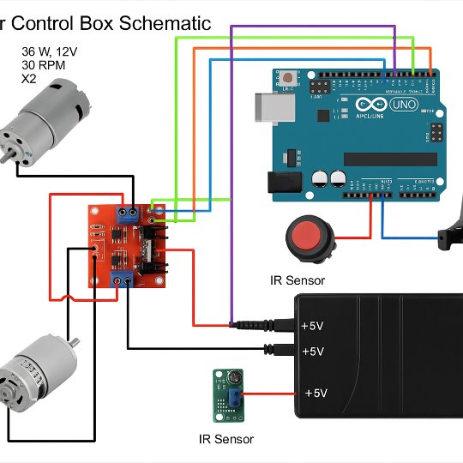

**Figure 54: Electrical Diagram of Motor Speed Test**

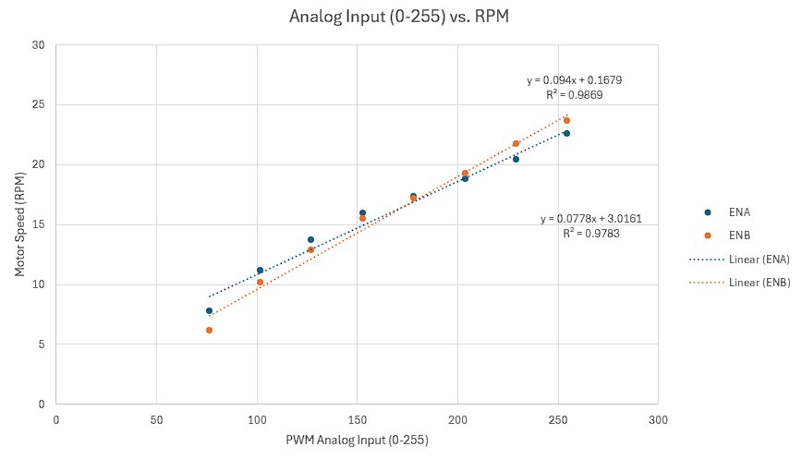

**Figure 55: PWM Input vs/ Motor Speed Calibration Results**

**Key Observations:**

* **Stiction Threshold:** Motors required >30% PWM input (~76.5 PWM out of 255) to overcome static friction and begin rotation.
* **Speed Underperformance**
  + Rated Speed: 30 RPM
  + Measured Steady-State Speed: ~22.5 RPM
* **Rise Time**
  + Approximately 5 seconds to reach steady-state RPM after activation.
* **Power Delivery Issues**
  + Motors did not consistently operate at their rated 35W output.
  + Lower-than-expected power resulted in reduced torque, affecting burrowing force at depth.

The table below demonstrates results when RPM was lowered, and depth was measured.

**Table 8. Motor RPM vs. Depth Performance**

|  |  |  |  |
| --- | --- | --- | --- |
| RPM | ENA PWM | ENB PWN | Depth (inches) |
| 22.8 | 255 | 255 | 3.5 |
| 22 | 244 | 232 | 2.75 |
| 18 | 192 | 190 | ~1” (Did not run) |
| 14 | 141 | 147 | Did not run |

**Key Takeaways:**

* **Motors are unable to achieve their rated 30 RPM** under load conditions.
* **Power instability affects torque output**, limiting soil penetration ability.
* **Longer burrowing times** and **increased energy consumption** are expected with current motors.
* **Future designs should select motors rated for 50 RPM** or higher, with more robust torque delivery to account for real-world resistance and avoid stalling.

Validation Test – Neural Network Performance

**Objective:** Validate the performance of the soil crop recommendation neural network model and assess its accuracy, loss, and potential for generalization.

**Test Setup and Procedure:**

* **Dataset Split**
  + 80% of the available data was used for training and 20% was reserved for testing.
  + The dataset included key features such as Nitrogen (N), Phosphorus (P), Potassium (K) content, Temperature, and Humidity.
* **Model Evaluation**
  + Evaluated model performance based on **accuracy** (correct predictions) and **loss** (error between predicted and true labels).
  + Loss and accuracy were monitored separately during both training and testing phases.

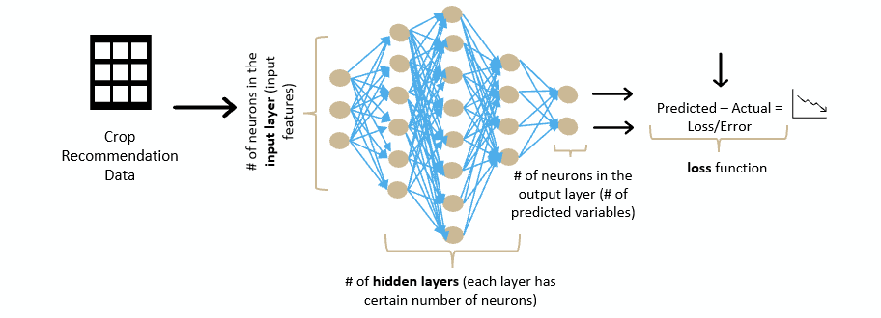

**Figure 56: Neural Network Diagram**

**Key Results**

* **Model Accuracy**
  + Achieved a **92% test accuracy**, exceeding the industry benchmark of 85% for agricultural recommendation systems.
* **Model Loss**
  + Observed **low and stable loss** during both training and testing.
  + Low loss indicates minimal difference between predicted and actual values, suggesting strong model generalization on unseen data.

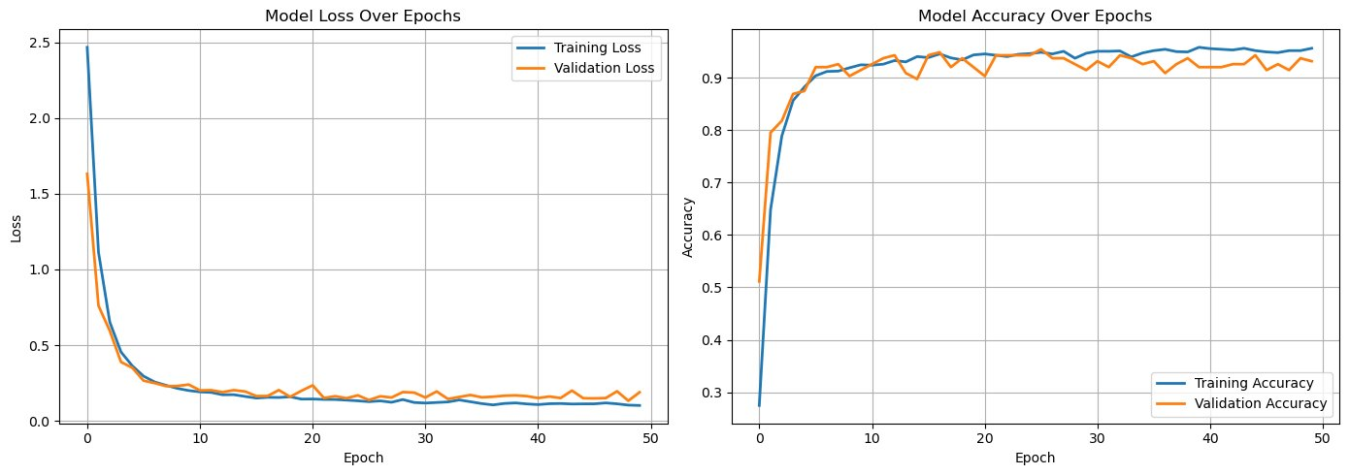

**Figure 57: Neural Network Performance Graphs (Loss & Accuracy)**

**Improvements and Limitations**

* **Current Dataset**
  + Model trained primarily on soil and weather data from India.
* **Limitations**
  + The model may not generalize perfectly to regions outside India without further training.
* **Future Improvement Recommendations**
  + Expand training dataset to include more diverse soil profiles and environmental parameters from multiple geographic regions.
  + Retrain the model periodically as more data becomes available to maintain high prediction accuracy.

1. **List of Standards Applied**
2. AGMA Standards – Gear Modeling and Rack-and-Pinion Design  
   (American Gear Manufacturers Association standards guided the modeling of rack-and-pinion components for accurate motion transfer.)
3. ANSI Y14.5 – Geometric Dimensioning and Tolerancing (GD&T)  
   (Applied basic GD&T practices for defining mechanical part features and tolerances in manufacturing drawings.)
4. ASTM Material Standards – Material Properties and Selection

(Referenced ASTM standards for evaluating material properties like strength, elasticity, and manufacturability during component selection.)

1. ASTM D1452 – Standard Practice for Soil Investigation and Sampling by Auger Borings  
   (Provided reference practices for soil sampling methods, ensuring sampling consistency.)
2. General ISO Best Practices for Safety and Testing  
   (Informally considered general ISO guidance for prototyping safety, electronics testing, and system integration.)
3. **References**

Crop Nutrition. (n.d.). *Third-party soil sampling: What you need to know.* Retrieved

February 6, 2025, from <https://www.cropnutrition.com/resource-library/third-party-soil-sampling-what-you-need-to-know/>

North Carolina State University Extension. (n.d.). *Careful soil sampling: The key to reliable*

*soil test information.* Retrieved February 6, 2025, from <https://content.ces.ncsu.edu/careful-soil-sampling-the-key-to-reliable-soil-test-information>

Soil Science Society of America. (n.d.). *Self-study exam: Soil sampling and testing.*

Retrieved February 6, 2025, from <https://www.soils.org/files/certifications/certified/education/self-study/exam-pdfs/243.pdf>

Shigley, J. E., Mishke, C. R., & Budynas, R. G. (2021). *Shigley's mechanical engineering design* (13th ed.). McGraw-Hill Education.

California Department of Transportation. (2011). *Trenching and shoring manual*.

Retrieved February 6, 2025, from <https://engineering.purdue.edu/~frosch/ftp/Talbott/11%20-%20References/files/California%20Trenching%20and%20Shoring%20Manual.pdf>

CB Insights. (n.d.). *Agriculture tech trends*. Retrieved February 6, 2025,

from <https://www.cbinsights.com/research/agriculture-tech-trends/>

Engineering News-Record. (n.d.). *Market data*. Retrieved February 6, 2025,

from <https://www.enr.com/market_data>

Gartner. (n.d.). *Market research methodologies*. Retrieved February 6, 2025,

from <https://www.gartner.com/en/research/methodologies/market-research>

Grand View Research. (n.d.). *Soil testing market size, share & trends analysis report*.

Retrieved February 6, 2025, from <https://www.grandviewresearch.com/industry-analysis/soil-testing-market>

Grand View Research. (n.d.). *Smart agriculture market size, share & trends analysis report*.

Retrieved February 6, 2025, from <https://www.grandviewresearch.com/industry-analysis/smart-agriculture-farming-market>

International Food Policy Research Institute. (n.d.). *Publications*. Retrieved February 6,

2025, from <https://www.ifpri.org/publications>

Mordor Intelligence. (n.d.). *Geotechnical engineering market - growth, trends, COVID-19*

*impact, and forecasts*. Retrieved February 6, 2025,

from <https://www.mordorintelligence.com/industry-reports/geotechnical-engineering-market>

NASA. (n.d.). *Earth science*. Retrieved February 6, 2025,

from <https://science.nasa.gov/earth-science/>United Nations Environment

Programme. (n.d.). *Resources*. Retrieved February 6, 2025, from <https://www.unep.org/resources>

United States Department of Agriculture, Economic Research Service. (n.d.). *Home page*.

Retrieved February 6, 2025, from [https://www.ers.usda.gov](https://www.ers.usda.gov/)

The World Bank. (n.d.). *Agriculture and rural development*. Retrieved February 6, 2025,

from <https://data.worldbank.org/topic/agriculture-and-rural-development>

Envirotecnics. (2020). *AMS soil sampling*. Retrieved February 6, 2025,

from <https://www.envirotecnics.com/wp-content/uploads/2020/07/AMS-soil-sampling-envirotecnics.pdf>